SENTINEL: AN INTEGRATED SECURITY OPERATIONS MANAGEMENT SYSTEM FOR DAVAO SECURITY & INVESTIGATION AGENCY, INC.

A Capstone Project
Proposal Presented to the Faculty of the
Information and Communications Technology Program STI College Tagum

In Partial Fulfillment
of the Requirements for the Degree Bachelor of Science in Information Systems

HANZ LOURENZ FRANK J. RIBU
HECTOR PHILLIP P. LACIERDA
APPLE JOHN D. LUMINGKIT
DWIGHT KARL B. GAGA-A
GAD ABRAHAM M. JOSE

October 2026

ENDORSEMENT FORM FOR PROPOSAL DEFENSE

TITLE OF RESEARCH: SENTINEL: An Integrated Security Operations Management System for Davao Security & Investigation Agency, INC.

NAME OF PROPONENTS: Hanz Lourenz Frank J. Ribu
Hector Phillip P. Lacierda
Apple John D. Lumingkit
Dwight Karl B. Gaga-a
Gad Abraham M. Jose

In Partial Fulfilment of the Requirements
for the degree Bachelor of Science in Information Systems
has been examined and is recommended for Proposal Defense.

ENDORSED BY:

Mr. Eldito C. Loquinio, MIT
Capstone Project Adviser

APPROVED FOR PROPOSAL DEFENSE:

Mr. Allimar M. Nuevo, MM, CGSP, CHIA
Capstone Project Coordinator

NOTED BY:

Mr. Eldito C. Loquinio, MIT
Program Head

May 12, 2026

APPROVAL SHEET

This capstone project proposal titled: SENTINEL: An Integrated Security Operations Management System for Davao Security & Investigation Agency, INC. prepared and submitted by Hanz Lourenz Frank J. Ribu, Hector Phillip P. Lacierda, Apple John D. Lumingkit, Dwight Karl B. Gaga-a and Gad Abraham M. Jose, in partial fulfillment of the requirements for the degree of Bachelor of Science in Information Systems, has been examined and is recommended for acceptance and approval.
Mr. Eldito C. Loquinio, MIT
Capstone Project Adviser

Accepted and approved by the Capstone Project Review Panel in partial fulfillment of the requirements for the degree of Bachelor of Science in Information Systems

Ms. Iris Mae Mendoza, MIT | Mr. Allimar M. Nuevo, MM, CGSP, CHIA
Panel Member | Panel Member

Mr. Benjamin M. Mahinay, MIT
Lead Panelist

Noted:

Mr. Allimar M. Nuevo, MM, CGSP, CHIA | Mr. Eldito C. Loquinio, MIT
Capstone Project Coordinator | Program Head

May 12, 2026

TABLE OF CONTENTS

SENTINEL: AN INTEGRATED SECURITY OPERATIONS MANAGEMENT SYSTEM FOR DAVAO SECURITY & INVESTIGATION AGENCY, INC. i
ENDORSEMENT FORM FOR PROPOSAL DEFENSE ii
APPROVAL SHEET iii
TABLE OF CONTENTS iv
INTRODUCTION 1
Project Context 1
Purpose and Description 3
Objectives 3
Scope and Limitations 6
Review of Related Literature/Studies/Systems 9
METHODOLOGY 19
Requirements Analysis 27
Design of Software, System, Product, and/or Processes 31
RESULTS AND DISCUSSION 55
Testing 55
Description of Prototype 55
Implementation Plan 56
Implementation Results 57
Summative Quantitative Evaluation 73
Respondent Comments 73
CONCLUSION 74
Summary of Key Findings 74
Evaluation of the Project 74
Implications and Contributions 74
Recommendations 75
REFERENCES 76

INTRODUCTION

Project Context
DASIA’s scheduling, attendance, replacement, and firearm-custody processes required information from separate records and communications. SENTINEL was developed to bring these records and checks into one system. Global research in workforce capacity indicates that manual, reactive responses to personnel gaps significantly increase vacancy time, which remains a primary driver of security breaches in critical infrastructure (Shiyanbola et al., 2023). This movement is supported by modern performance management theories which emphasize that transparent, data-driven tracking is essential to maintaining accountability and preventing social loafing, a phenomenon where individual reliability decreases in the absence of structured, real-time monitoring (Aguinis, 2022).
The necessity for these technological advancements is echoed in recent Philippine legislation through the Private Security Services Industry Act, also known as Republic Act No. 11917 (2022). This law introduced a regime of professionalized accountability where agencies face strict liability for administrative negligence. Under the law’s Implementing Rules and Regulations, agencies can be fined up to P5,000,000 or face license revocation for deploying personnel with expired licenses or unauthorized firearms (Jur.ph, 2025). Furthermore, national studies on the effectiveness of Philippine security guards identify that absenteeism and the abandonment of posts are most prevalent in agencies that lack advanced patrol monitoring and digital reporting systems (Abad, 2025).
In the specific context of the Davao Region, the Davao Security and Investigation Agency, Inc. operates in a landscape that has prioritized a culture of security to sustain its position as a leading safe haven in Southeast Asia (PIA, 2025). According to the Davao Regional Development Plan 2023 to 2028, the region's rapid economic growth has increased the demand for advanced technology and innovation to ensure peace and security in high-traffic logistics and commercial hubs like Tagum City (NEDA XI, 2024). Recent local research conducted in the Davao Region specifically highlights that compensation, punctuality, and alertness are the primary determinants of guard performance, yet many regional agencies still struggle with inattentiveness and abandonment of posts due to inconsistent manual oversight (Ondos and Origines, 2025). For DASIA Tagum, this represents a critical vulnerability where a missed duty could delay replacement coordination when the schedule, attendance status, and available Guards had to be checked separately.
SENTINEL is an integrated security operations platform designed to address these vulnerabilities by centralizing personnel profiles, firearm inventory and custody records, and shift logs into a unified source of operational data. The scheduling workflow validates that guards are approved and checks for conflicting assignments before a schedule is created. Firearm allocation separately validates firearm availability, permit status, and applicable firearms-handling training before normal issuance. When a no-show condition is detected, SENTINEL can notify eligible guards and provide ranked replacement recommendations based on operational factors such as reliability, availability, permit status, and last-known distance. Authorized personnel or an eligible guard then confirm the reassignment. To manage high-concurrency requests from hundreds of guards, SENTINEL utilizes the Rust programming language and the Axum framework, providing native memory safety and asynchronous performance that prevents the data races typical of legacy systems (Scofield, 2025).

Purpose and Description
The purpose of this capstone project was to develop and assess SENTINEL as an integrated security operations management system for Davao Security & Investigation Agency, Inc. The study addressed fragmented manual oversight by bringing personnel, operational, asset, and governance records into a role-governed environment for command and field workflows.
SENTINEL consolidated identity and access governance, workforce administration, asset and permit information, incidents, support and notification workflows, and operational monitoring. Approval and policy controls restricted sensitive functions to authorized users and preserved traceable records for review.
At the command level, the platform combined available location information with structured operational records to show deployment conditions, incidents, and site activity. Notifications, Inbox timelines, and incident workflows supported coordination across command and field roles.
The Web application served as SENTINEL’s primary runtime. The Windows desktop application packaged with Tauri and the Android application packaged with Capacitor were installed and successfully tested on their intended platforms.

Objectives
General Objective
The main objective of the study was to develop SENTINEL, an integrated, role-governed security operations management system for Davao Security & Investigation Agency, Inc. Specifically, the study aimed to:
Specific Objectives
- Provide secure, approval-governed user access with identity verification, session management, account recovery, and legal-policy compliance.
  - Support administrator-mediated account onboarding, verification, approval, secure authentication, and password recovery.
  - Enforce role-based access and account-activation controls for Superadmin, Administrator, Supervisor, and Guard users.
  - Maintain secure session continuity, account protection, sign-out revocation, and legal-policy acceptance with traceable records.
- Automate personnel operations, including scheduling, attendance, DTR generation, check-in/check-out, and replacement coordination.
  - Maintain guard personnel records, human-readable Guard IDs, schedules, client-site assignments, and personnel availability information.
  - Record attendance, check-in and check-out activities, generate DTR records, and identify schedule conflicts and no-show conditions.
  - Support guard replacement coordination through eligible-guard notification, availability checking, ranked replacement recommendations, and confirmed reassignment.
- Strengthen firearm, permit, vehicle, and asset accountability through reports, expiration alerts, issuance tracking, and maintenance monitoring.
  - Maintain centralized records for firearms, firearm permits, vehicles, driver assignments, trips, and related operational assets.
  - Track firearm issuance, custody, return, permit validity, applicable training requirements, and asset availability.
  - Monitor permit expirations, vehicle and firearm maintenance activities, asset status, and accountability records through alerts and operational reports.
- Support field operations through incident reporting, emergency escalation, service requests, notifications, and live monitoring.
  - Enable guards and authorized users to submit incident reports, support requests, emergency alerts, and panic escalations.
  - Provide near-real-time operational visibility through location tracking, movement history, client-site information, geofence monitoring, and operations-map views.
  - Deliver role-appropriate notifications, Inbox workflows, mission information, and selected offline support for priority field actions.
- Provide performance evaluation and analytics through graphical reports on attendance, punctuality, incidents, assignments, and guard performance.
  - Generate graphical reports and operational summaries covering attendance, punctuality, incidents, assignments, and guard-performance indicators.
  - Apply rule-based scoring and analytical methods to support merit evaluation, risk identification, replacement recommendations, and operational alerts.
  - Provide authorized command users with dashboards and filtered analytical information for personnel evaluation and operational decision-making.
- Deliver a traceable security operations system with an implemented Web application and configured Windows desktop and Android deployment targets, supported by audit logs, approval workflows, and operational reports.
  - Provide role-governed access through the implemented Web application and configure Windows desktop and Android deployment targets using shared application services and centralized operational data.
  - Maintain audit logs, approval histories, security events, and user-action records to support accountability and forensic review.
  - Generate traceable operational reports and maintain system records that support governance, compliance review, and institutional monitoring.

Scope and Limitations
Scope
The study covered the implemented operational, compliance, and governance functions of SENTINEL within the private-security context of Republic Act No. 11917 (2022). The Web application served as SENTINEL’s primary runtime. The Windows desktop application through Tauri and the Android application through Capacitor were installed and successfully tested on their intended platforms.
Data
- Personnel profiles, human-readable Guard IDs, role and approval data, licensing and permit records, schedules, attendance logs, availability status, merit indicators, and legal-consent records.
- Firearm inventory records, allocations, maintenance history, and permit-compliance data.
- Armored vehicle assets, allocations, driver assignments, trip records, and maintenance history.
- Missions, incidents, support tickets, notifications, operational alerts, emergency alerts, location records, Inbox summaries, workflow history, and audit logs.
- Geofence events, site geofence definitions, movement-history records, forensic activity traces, and anomaly evidence for post-incident review.
- Authentication lockout records, session lifecycle records, and audit source-IP traces for security accountability.
- Release and service-health records required for runtime governance and operational monitoring.
Process
- Account lifecycle workflows, including controlled onboarding, verification, authentication, recovery, and profile maintenance.
- Approval workflows for newly onboarded guard accounts before operational access is granted.
- Role-based dashboards for command monitoring, approvals, analytics, scheduling, audit review, and profile management.
- Desktop command dashboards supported adjustable navigation density while preserving usable shell behavior across desktop and mobile form factors.
- Role-based inbox and quick-action workflows for prioritized tasks, approvals, incidents, notifications, asset-related actions, shift issues, and workflow history.
- Mission-first guard workflows for field reporting, attendance actions, instructions review, emergency-contact access, panic escalation, selected offline continuity, and map-supported navigation.
- Shift scheduling, attendance validation, no-show detection, replacement coordination, and supervisor oversight.
- Firearm issuance and return workflows with permit validation, maintenance scheduling, and custody traceability.
- Vehicle allocation, driver assignment, trip lifecycle management, and preventive and corrective maintenance tracking.
- Incident reporting, emergency escalation, support-ticket handling, notification delivery, and live operational monitoring.
- Guard movement reconstruction, including active roster monitoring, historical trail replay, patrol reconstruction, and geofence escalation.
- Audit forensics workflows, including timeline filtering, actor-specific activity reconstruction, anomaly review, and case sequencing.
- Session security workflows, including renewal control, sign-out revocation, and lockout persistence.
- Legal confirmation workflows, including policy review, mandatory acceptance capture, and access gating until accepted.
People
- Superadmin, Administrator, Supervisor, and Guard roles with distinct permissions and dashboard views.
Technology
- Web-based application accessible on desktop and mobile browsers.
- Windows desktop application packaged with Tauri and Android application packaged with Capacitor, installed and tested on their intended platforms.
- React + TypeScript frontend and Rust + Axum backend services.
- Centralized PostgreSQL database with relational integrity, auditability, and role-based data control.
- Dockerized deployment and service-based architecture with live tracking synchronization, audit telemetry, and governed release packaging.
Limitation of the Study
The limitations of this study refer to the exclusions and constraints that were beyond the intended scope and implementation coverage of the developed system. These include, but are not limited to: (1) the exclusion of direct integration with external payroll systems, human resource platforms, government licensing databases, and third-party security hardware ecosystems such as CCTV, IoT sensors, and access-control devices; (2) technological constraints related to the system’s dependence on application-generated location updates, device GPS accuracy, network stability, and the provision of only partial offline support for selected high-priority guard actions. While GPS-based tracking provides more accurate and reliable location data for operational monitoring, IP-based location tracking remains less precise and may not consistently reflect the exact real-time position of field personnel; and (3) implementation constraints, wherein certain backend-supported capabilities, such as direct training-record administration and full geofence-zone administration, are not yet fully exposed through complete end-user command surfaces, while some workflows remain consolidated within shared dashboard panels, tabs, and shell overlays rather than being deployed as fully independent standalone modules.

Review of Related Literature/Studies/Systems
Related Literature
The Philippine private security sector is currently navigating its most significant legal transition in over fifty years. The enactment of the Private Security Services Industry Act (Republic Act No. 11917, 2022) effectively repealed the outdated RA 5487, shifting the industry toward a regime of "Professionalized Accountability." According to Jur.ph (2025), the law’s Implementing Rules and Regulations (IRR) mandate that Private Security Agencies (PSAs) maintain highly accurate, digitized records of License to Exercise Security Profession (LESP) and firearm permits. The act introduces a "strict liability" framework where administrative negligence, such as deploying an unlicensed guard, can result in fines ranging from ₱50,000 to ₱100,000 per violation, or up to ₱5,000,000 for agency-wide license failures.
This regulatory pressure has necessitated a move toward Automated Regulatory Compliance Tracking (ARCT). Research by Khinvasara, T., Shankar, A., & Wong, C. (2024) suggests that for organizations managing complex, shifting rules, the use of automated monitoring is a "significant advancement" that eliminates the "discovery lag" inherent in manual audits. By leveraging system-driven triggers for license expirations, PSAs can transition from reactive compliance to a proactive stance, ensuring that no personnel or asset is deployed without valid legal authorization.
Operational continuity in the private security sector is heavily dependent on reliable guard presence. As identified in the operational risks of DASIA Tagum, "No-Show" incidents represent a critical vulnerability where manual processes relying on phone calls and delayed human intervention fail to address "discovery lag." Research in workforce capacity optimization emphasizes that manual, reactive responses to workforce gaps significantly increase "vacancy time," directly correlating with higher security breach probabilities (Shiyanbola et al., 2023).
Modern systems mitigate this by automating the identification and deployment of replacements based on real-time availability, shifting the organizational stance from reactive crisis management to proactive risk mitigation (Al-Khafajiy et al., 2022). Furthermore, automated scheduling alerts now enable "rule-based no-show monitoring", which analyzes historical No-Show data to alert administrators of potential gaps before they occur, drastically reducing the operational vacancy time (TrackTik, 2025).
The transition from inconsistent, manual tracking to a structured, data-driven framework is essential for maintaining Distributive Justice, the perceived fairness of how shifts, rewards, and responsibilities are allocated within an organization. Aguinis (2022) posits that the absence of a structured performance management framework leads to "Social Loafing," a psychological phenomenon where employees decrease effort due to a perceived lack of individual accountability.
For security agencies like DASIA Tagum, implementing centralized performance metrics such as punctuality and client feedback logs ensures that shift allocation is based on objective data rather than subjective selection. This transparency not only increases overall guard reliability but also fosters a culture of accountability, as guards understand that their performance is directly linked to future opportunities (Tan et al., 2024).
The systematic allocation of firearms is a matter of both Chain of Custody (CoC) and legal necessity under the Private Security Services Industry Act (Republic Act No. 11917, 2022). The law mandates strict accountability for firearms, requiring that only authorized, trained, and compliant guards carry weapons. Manual processes often suffer from "data drift," where the status of a weapon and the permit validity of the assigned guard are not reconciled in real-time, leading to potential administrative negligence. Centralized digital tracking is identified as the primary defense against the misallocation of high-risk equipment and is a prerequisite for generating the legally defensible audit logs required by the National Cybersecurity Plan 2023–2028 (DICT, 2024; PNP-SOSIA, 2022).
The selection of the backend technical stack is a core security decision for mission-critical systems. Scofield, M. B. (2025) argues that Rust’s "ownership and borrowing" model provides a fundamental architectural advantage: Memory Safety without a Garbage Collector. This ensures that SENTINEL is natively resistant to buffer overflows and data races, vulnerabilities that often plague systems handling high-concurrency data like real-time firearm tracking.
Complementing the language is the Axum framework, which is built on the Tokio asynchronous runtime. As highlighted by NashTech (2025), Axum is designed for high-performance web services where scalability and raw speed are non-negotiable. SENTINEL’s Attendance Tracking and No-Show Detection modules used the Rust and Axum backend for check-in and staffing updates. This "asynchronous-first" design allows the system to remain responsive even when processing complex relational logic across personnel, vehicle, and firearm databases.
In an Integrated Operations Platform, the database must serve as the immutable "Single Source of Truth." PostgreSQL (2025) is recognized as the premier open-source RDBMS for enterprise planning due to its strict adherence to ACID (Atomicity, Consistency, Isolation, Durability) properties. Nguyen, R. (2025) emphasizes that PostgreSQL’s implementation of Foreign Key Constraints and Unique Exclusion Constraints is the primary defense against "data drift."
In the SENTINEL ecosystem, these constraints ensure that a firearm or armored vehicle cannot be logically "double-booked" or assigned to a guard who does not exist in the personnel table. This high level of relational integrity is a prerequisite for generating the legally defensible Audit Logs required by the National Cybersecurity Plan 2023-2028 (DICT, 2024), ensuring that every asset movement is tied to a verifiable digital identity.
Empirical research confirms that automated oversight is a primary driver of operational integrity. A study by Atlam, H. F., & Yang, Y. (2025) found that organizations utilizing unified Access Control and Resource Planning (ERP) systems saw a 27% drop in unauthorized access violations and reclaimed 36% of staff time previously lost to manual verification. These findings suggest that hardwiring compliance into the system architecture, rather than treating it as an afterthought, tightens process integrity and reduces the risk of internal data tampering.
Furthermore, research by Shiyanbola, J. O., et al. (2023) on "Workforce Capacity Optimization" highlights a flaw in traditional security: "discovery lag." This occurs when supervisors only identify a personnel gap after a shift has failed. Their study demonstrates that real-time, asynchronous detection models allow for a proactive 11.8% improvement in site coverage reliability. Locally, ResearchGate (2025) cites a study by Respicio (2023) which found that Philippine security guards operating under digital monitoring exhibited significantly higher levels of alertness and punctuality because the system provided a transparent, inescapable layer of accountability that manual logs could not match. The functional blueprint of SENTINEL is informed by the performance of several industry-leading platforms such as TrackTik and Guardhouse.
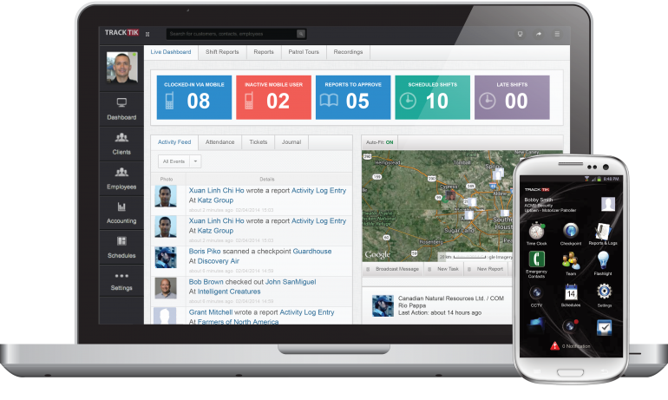
Figure 1. TrackTik
TrackTik (2025) has redefined security workforce management by moving beyond static scheduling toward an integrated, AI-driven operational model. According to the Trackforce 2025 Physical Security Operations Benchmark Report, the industry is currently facing an "AI adoption paradox" where the value of predictive scheduling is recognized, but cost remains a barrier for mid-sized firms. TrackTik’s success is anchored in its ability to consolidate alarm monitoring, guard dispatch, and business administration into a single 24/7 resilient architecture, which users report has increased operational efficiency by approximately 20%. This efficiency is primarily attributed to the reduction of manual administrative burdens through automated compliance tracking and real-time intelligence feeds (TrackTik, 2025).
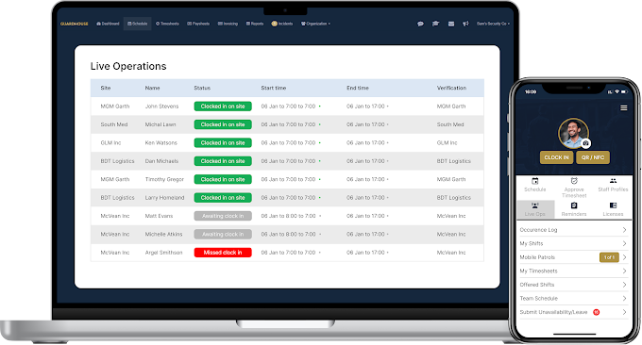

Figure 2. Guardhouse
Guardhouse (2026) addresses the specific administrative "overload" that has become a measurable barrier to performance in the mid-2020s. Research from NODE Magazine (2026) indicates that security employees often lose an average of 15 hours per week to routine administrative tasks, such as re-entering data across fragmented systems. Guardhouse mitigates this by unifying scheduling, GPS tracking, and invoicing into a streamlined workflow, reportedly reducing office-based administrative time by 40–60%. Its "Confidence in Compliance" module provides a specialized framework for daily license verification, a logic that SENTINEL adapts to specifically meet the stringent requirements of RA 11917 (GetApp, 2026).

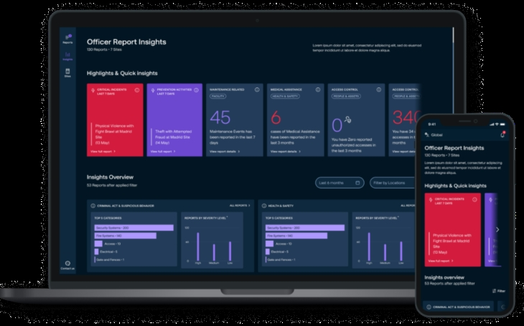
Figure 3. MySecuritas
Securitas "MySecuritas" (2026) represents the industry’s shift toward "Situational Understanding" and proactive risk management. The Securitas 2026 Global Technology Outlook Report identifies that the rapid advancement of generative AI for contextual understanding is now a top priority for 30% of security decision-makers (Securitas Technology, 2025). MySecuritas operationalizes this by providing a unified dashboard that transforms disparate incident reports into actionable statistics and trend highlights. This allows supervisors to identify risk patterns before they escalate, a core design principle mirrored in SENTINEL’s Performance Analytics Dashboard (Securitas, 2026).

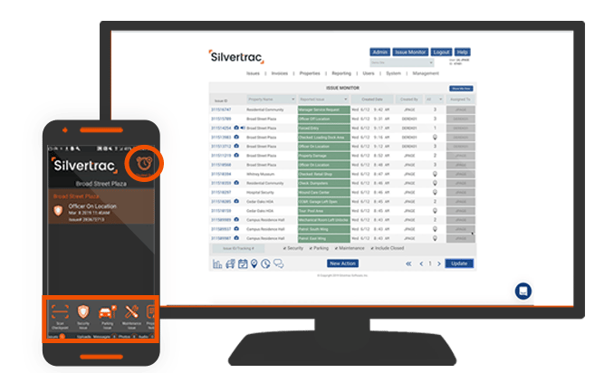

Figure 4. Silvertrac Software
Silvertrac Software (2026) is widely utilized for "Proof of Performance" and on-site accountability, particularly in parking and property management environments. While it excels in field reporting and checkpoint verification via mobile applications, its architectural focus remains on incident management and officer accountability (Silvertrac Software, 2026). Technical evaluations of generic guard management systems suggest a persistent "visibility gap" in specialized asset tracking; most platforms lack the deep relational logic required for a Digital Chain of Custody for high-risk assets like firearms and armored car fleets (Hardcat, 2025). SENTINEL fills this niche by integrating these high-stakes logistics, traditionally managed in siloed armory or fleet software, into the primary workforce management ecosystem.
Across the reviewed literature, several consistent themes emerge. Researchers emphasize the importance of integrating operational data to improve organizational visibility and decision-making. Studies from both Philippine and international contexts highlight the limitations of fragmented monitoring tools and manual processes.
Technological trends such as automated scheduling algorithms, attendance tracking, and operational dashboards are increasingly adopted across industries. However, existing systems often address only a single domain of operations, such as workforce scheduling or surveillance monitoring. Global systems like TrackTik and Guardhouse demonstrate that the industry standard is defined by Real-Time Accountability and Centralized Data Ownership. However, these systems often fail to accommodate the granular administrative nuances of Philippine law.
The reviewed literature therefore reveals a clear research gap in integrated systems that combine workforce management, compliance monitoring, and operational oversight within a unified platform tailored to security agencies. The SENTINEL system addresses this void by combining high-concurrency Rust/Axum architecture with modules specifically for Philippine-specific licensing (RA 11917), Firearm Custody, and Armored Car Fleet Management, allowing local agencies to achieve multinational levels of visibility and compliance. It provides a centralized solution that integrates scheduling automation, regulatory compliance verification, and real-time operational dashboards within a single enterprise system.

METHODOLOGY
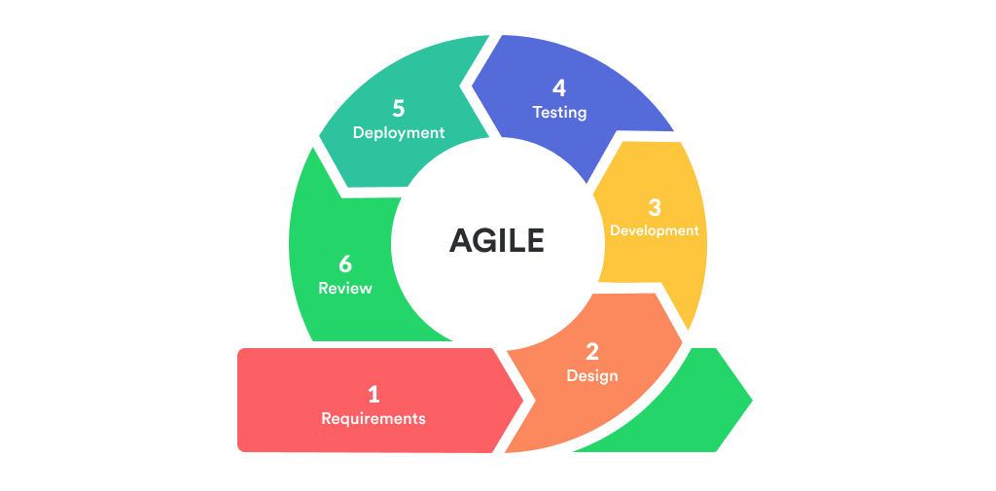
This study adopted Agile methodology, specifically Scrum, to deliver SENTINEL through incremental, testable, and reviewable capability sets.
Figure 5. Agile Model
Development was organized into successive sprints that covered planning, implementation, integration, validation, packaging, review, and refinement. Each sprint used prioritized backlog items tied to operational risk and institutional requirements.
Sprint planning and backlog refinement emphasized high-risk domains, including account governance, workforce continuity, asset compliance, incident coordination, movement monitoring, notification and inbox workflows, guard-safety functions, and decision-support features. Regular integration checkpoints ensured consistency of workflows, system rules, and data behavior.
Validation was embedded throughout the Scrum cycle through scenario-based testing, integration checks, role-permission verification, browser-based acceptance review, and cross-platform runtime review. Sprint reviews documented completed increments, while acceptance checks verified that each increment satisfied defined criteria before carry-forward.
Release readiness was evaluated through structured quality checks, build verification, and governed platform packaging before each major milestone to support controlled rollout decisions and reduce operational disruption. Overall, the methodology shows an Agile approach in which reliability, accountability, security, and usability were developed together with functional scope.

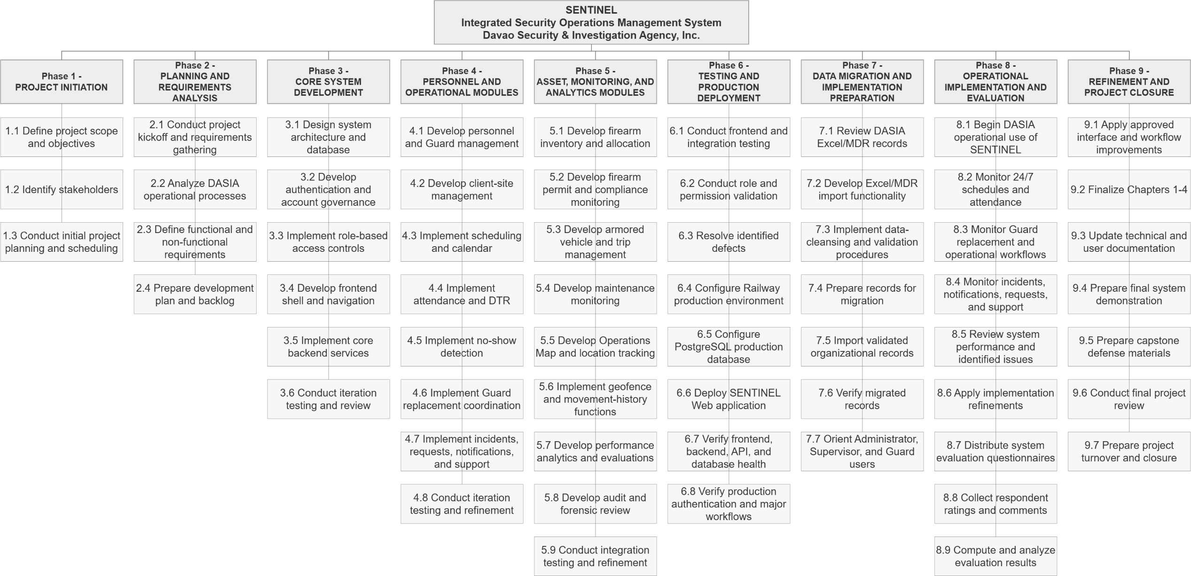
Figure 6. Work Breakdown Structure
Technical Background
Technologies used in the System
SENTINEL was implemented as a Web-first security operations platform with Windows desktop and Android applications. The selected stack supported role-governed dashboards, API services, relational records, tracking, and shared application services. Development and testing used Windows computers with at least 8 GB RAM, SSD storage, and stable internet access; 16 GB RAM improved multitasking.
- React + TypeScript: Used to build reusable, role-aware UI components and dashboard modules with strict typing.
- Vite: Used pipelines for local development and production.
- Tailwind CSS: Used for responsive interface implementation across command-center, operations, and resource modules.
- Leaflet + OpenStreetMap: Used for operational map rendering, live marker visualization, and client-site management.
- Rust + Axum: Used for backend API handlers, middleware, and service orchestration.
- PostgreSQL: Used as the central transactional database for users, approvals, schedules, attendance, firearms, vehicles, incidents, notifications, tracking points, and audit logs.
- Docker + Docker Compose: Used to standardize local backend/database orchestration and deployment parity.
- Secure token-based authentication: Used to enforce protected access and stable session management across user roles.
- Capacitor: Used to package the web frontend for Android field deployment.
- Tauri: Used to package the same frontend for Windows desktop command-center deployment.
- Resend: Used for transactional email delivery such as verification codes, password reset codes, and operational notifications.
- Railway: Used as a cloud deployment platform for backend runtime and managed service hosting.
- Namecheap: Used for domain registration and domain-level DNS management.
- Git and GitHub: Used for version control, collaboration, change tracking, and managing the release of MSI and EXE files.
- Android release signing tooling: Used to generate, encode, and manage the release keystore required for signed APK and AAB distribution, supporting controlled and verifiable release governance for the Android deployment target.

Gantt Chart of Activities
MONTH | FEBRUARY |  |  |  | MARCH |  |  |  | APRIL |  |  |  | MAY |  |  |  | JUNE |  |  |  | JULY |  |  |  | AUGUST |  |  |  | SEPTEMBER |  |  |  | OCTOBER |  |  |  | NOVEMBER |  |  |  | DECEMBER
ACTIVITY
Project Initiation
Planning & Requirements
Core System Development
Personnel & Operational Modules
Asset, Monitoring & Analytics
Testing & Production Deployment
Data Migration & Preparation
Operational Implementation & Evaluation
Questionnaire distribution
Refinement & Documentation
Maintenance & Project Closure
Figure 7. Gantt Chart of Activities
Completed | Ongoing |  | Not Started

Legends:

Calendar of Activities
Figure 7 presents the project schedule and the duration of its completed phases. The calendar summarizes the same sequence, including the major activities, people involved, and resources used.
Table 1. Calendar of Activities
Month | Activity | Purpose
February 2026 | Phase 1 - Project Initiation | Defined the project scope, objectives, stakeholders, and initial development direction.
March 2026 | Phase 2 – Planning and Requirements Analysis | Gathered requirements, organized the backlog, conducted planning, and defined system requirements.
April - May 2026 | Phase 3 - Core System Development | Developed the system architecture, database, authentication, access controls, and core application structure.
June - July 2026 | Phase 4 – Personnel and Operational Modules | Implemented scheduling, attendance, DTR, replacement coordination, incidents, notifications, and support workflows.
August - September 2026 | Phase 5 – Asset, Monitoring, and Analytics Modules | Completed firearm, vehicle, tracking, analytics, reporting, audit, and related operational features.
September 2026 | Phase 6 – Testing and Hosted Deployment | Conducted integration testing, resolved defects, configured hosted services, and deployed the Web application.
September–October 2026 | Phase 7 – Data Migration and Preparation | Prepared source records for migration and developed the Excel/MDR import and data-cleansing functions.
October 2026 | Phase 8 – Operational Implementation and User Evaluation | Validated the workflows, collected completed evaluation questionnaires from participating DASIA personnel, and reviewed system performance.
October 2026 | Phase 9 – Refinement and Documentation | Reviewed findings, addressed identified issues, updated the manuscript, and prepared the defense documentation.
November–December 2026 | Phase 10 – Maintenance and Project Closure | Performed final refinements, complete turnover documentation, finalize project outputs, and prepare for project closure.
Table 1 summarizes the recorded project phases and activities for SENTINEL.

It outlines the work from initiation and requirements through development, validation, hosted deployment, data preparation, evaluation, and documentation.

Requirements Analysis
Table 2. Comparison of the Existing Process and the Implemented Process
Process Area | Existing / Old Process | Implemented Process in SENTINEL | Record or Output in SENTINEL
Scheduling and workforce continuity | Scheduling, attendance, no-show detection, and replacement coordination depend on manual monitoring and delayed communication. | SENTINEL centralizes schedules, attendance actions, no-show detection, and replacement workflows in a unified operational platform. | Shift assignment, attendance entry, DTR, and replacement record.
Asset and compliance monitoring | Firearm, permit, vehicle, and trip records are managed through separate or manual records, increasing compliance and traceability risks. | SENTINEL manages firearm, permit, vehicle, trip, and maintenance workflows through centralized and auditable records. | Firearm inventory and custody record, permit information, vehicle allocation, and trip record.
Incident handling and live monitoring | Incident reporting and field monitoring rely on manual updates, weak patrol visibility, and delayed supervisory awareness. | SENTINEL provides structured incident workflows, notifications, live tracking, geofence monitoring, and command dashboards. | Incident report, operational request, notification, and available location record.
Auditability and decision support | Operational review depends on scattered records and manual analysis, limiting traceability and data-driven decision-making. | SENTINEL provides audit logs, forensic visibility, operational dashboards, analytics, reports, and rule-based alert outputs. | Audit entry identifying the actor, action, timestamp, and related record; dashboard and report output.
Table 2 compares DASIA’s existing procedures with the corresponding SENTINEL functions. The comparison covers scheduling and replacement, firearm and vehicle records, incident monitoring, and audit review.
The functional requirements were organized around the four user roles. They included account approval and access restrictions; Guard and site records; shift scheduling, attendance, DTR, and replacement; firearm issuance and return; vehicle allocations and trips; incidents and notifications; analytics; and audit records. Each function used the same backend services and PostgreSQL database so related records could be reviewed across modules.
React, TypeScript, and Vite were used for the interface; Rust and Axum for the API; PostgreSQL for relational records; and Leaflet with OpenStreetMap for map display. Tauri packaged the Windows desktop application, while Capacitor packaged the Android application. The Web, Windows desktop, and Android applications were implemented and tested.
- All Users
  - The system supported administrator-mediated onboarding, verification, approval, secure authentication, password-reset workflows, role-based access control, mandatory legal-policy acceptance, and access through the Web, Windows desktop, and Android applications.
- Superadmin
  - The system provided superadmin users with command-level dashboards, shared quick Inbox workflows, analytics, performance reports, and operational alerts, ticketing and notification visibility, a feedback dashboard for aggregate and record-level review, audit-log visibility, and forensic audit review for investigative review.
- Admin
  - The system enabled administrator users to govern personnel workflows, support scheduling and workforce coordination, manage firearm and armored vehicle lifecycle records, access command dashboards and quick Inbox workflows, handle operational ticketing and notifications, and submit authenticated feedback through the constrained feedback workflow.
- Supervisor
  - The system enabled supervisor users to monitor schedules, attendance, no-show conditions, and replacement actions; access near-real-time tracking, movement history, active deployment, and geofence-alert views; manage authorized operational resources including guard accounts, firearms, vehicles, and client sites; create guard accounts subject to administrator approval; access command dashboards, quick Inbox workflows, reports, alerts, and operational summaries; manage ticketing and notification workflows; and submit authenticated feedback. Supervisors did not create Supervisor, Admin, or Superadmin accounts, delete user accounts, or modify the system's role-permission policy.
- Guard
  - The system enabled guard users to access personal schedules and assigned resources, perform attendance-related actions, receive and respond to notifications, submit incident and support-related workflows, use self-scoped live tracking and movement-history features subject to policy and consent controls, access mission-critical field actions such as panic escalation, and submit authenticated feedback.

Non-functional Requirements
The non-functional requirements of SENTINEL emphasize security, performance, usability, reliability, scalability, and compliance traceability. In terms of security, the system enforced strong authentication, role-based authorization, approval-gated access, auditable security events, account-protection controls, and abuse-resistance measures to preserve the integrity of operational data and workflows. In terms of performance, the system maintained responsive dashboards and timely operational updates suitable for near-real-time supervisory decision-making. With respect to usability, the system provided role-centered dashboards and modular user-interface navigation that reduce operator context switching, while further minimizing workflow friction through the use of a shared quick Inbox action for urgent operational work and timeline context. In terms of reliability, the system maintained secure session continuity, renewal, and termination behaviors to protect ongoing operations. With respect to scalability, the system architecture remained API-driven and modular so that additional modules, integrations, and platform targets may be introduced without requiring a full redesign. Finally, for compliance traceability, legal acceptance and policy-governance events were recorded with timestamped metadata suitable for institutional review, accountability, and regulatory compliance.

Design of Software, System, Product, and/or Processes
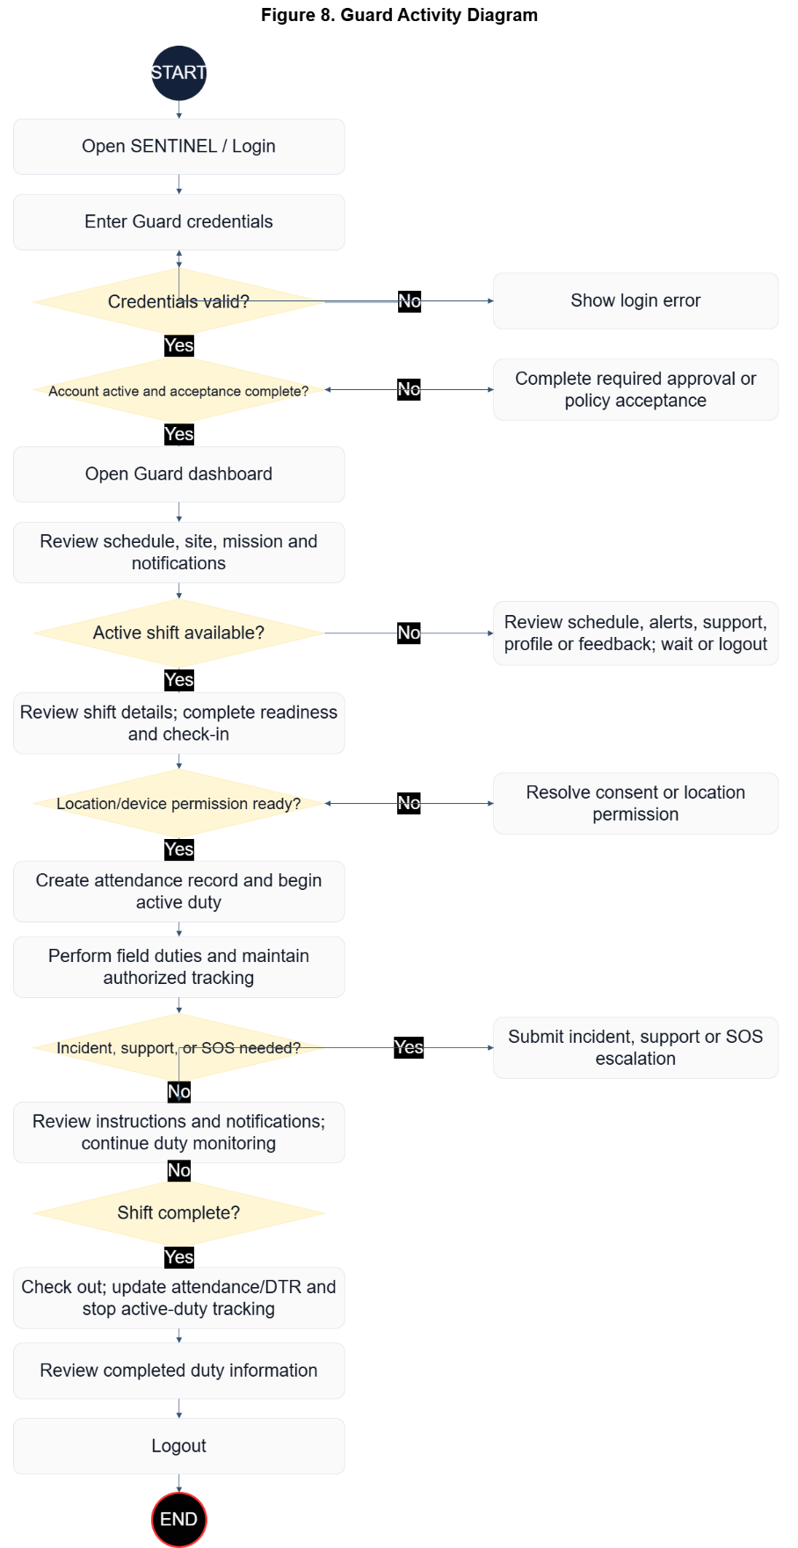
Figure 8. Guard Activity Diagram
Figure 8 illustrates the Guard workflow from authentication to duty completion and secure logout. The flow first validates credentials, then verifies whether account approval and policy acceptance are already in a valid state; if a requirement is missing, the guard completes the required approval or acceptance step before dashboard access proceeds. From the mission-first guard dashboard, the process branches based on whether an active shift is available. If no active shift is assigned, the guard remains on non-duty activities such as reviewing alerts, sending support concerns, and updating profile details. If an active shift exists, the guard performs check-in, confirms location/device access for tracking, executes patrol or assigned field duty, and stays in a duty-monitoring loop. When an incident or urgent support event occurs, the guard submits an incident or panic/support escalation record, then returns to monitoring until check-out and session closure.
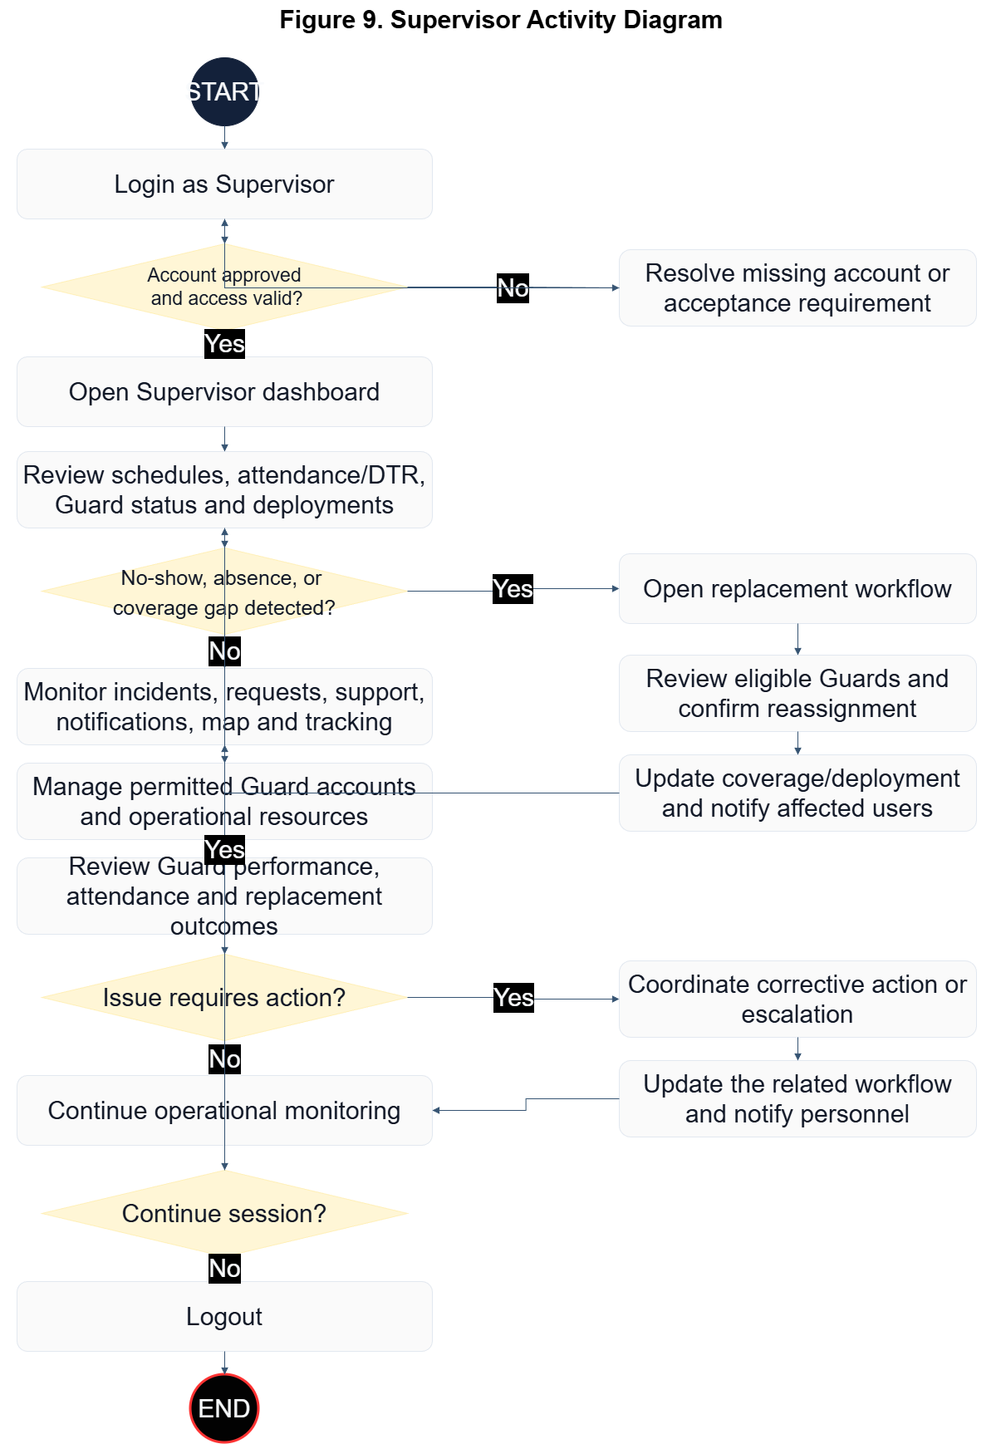
Figure 9. Supervisor Activity Diagram

Figure 9 presents the Supervisor workflow from authenticated access to end-of-session review. After login and access-state validation, the supervisor opens the dashboard to inspect schedules, attendance, and team status. The main control point is staffing-gap detection: when no-show, absence, or coverage gaps are detected, the supervisor initiates replacement coordination by selecting available personnel, issuing reassignment, and confirming deployment before updating operational status. When no immediate gap exists, the supervisor continues command monitoring activities, including incidents, alerts, and support workload. The workflow then moves to live tracking and team-performance review, with an escalation branch for operational issues that requires corrective action logging before returning to monitoring, followed by secure logout.
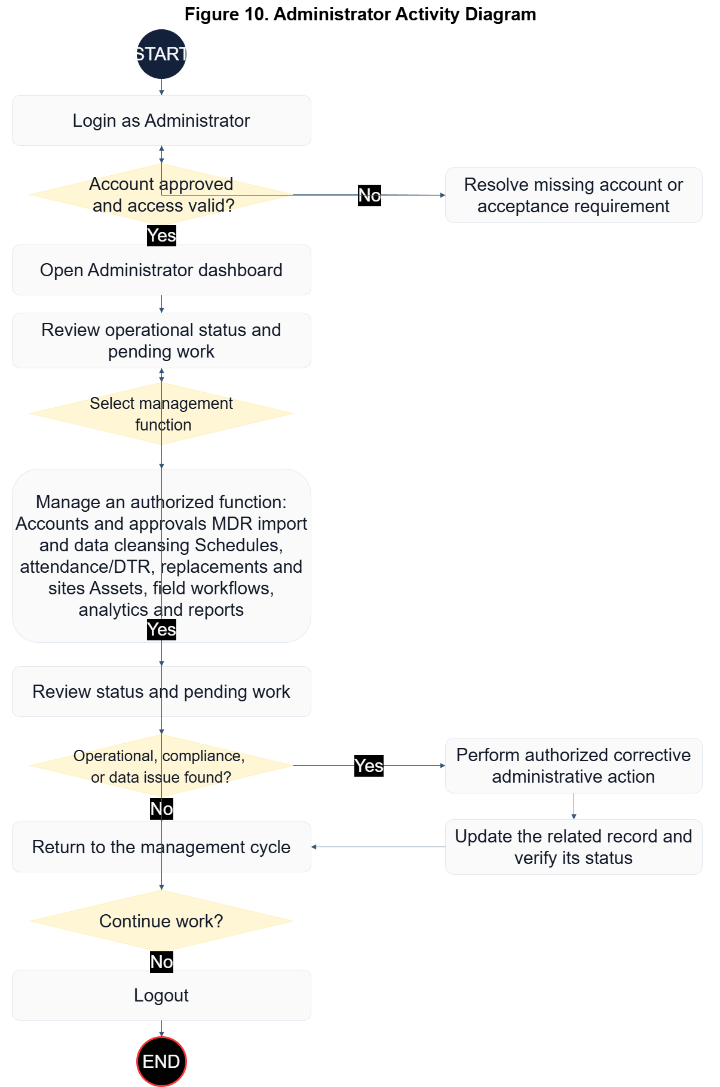
Figure 10. Administrator Activity Diagram

Figure 10 outlines the Administrator workflow as a governed control cycle rather than a single fixed sequence. After successful authentication and access-state checks, the administrator enters the command dashboard and selects the required management function: user/approval records, scheduling and assignment records, or asset/compliance records (firearm, permit, vehicle, and trip). After each management action, updates are reflected in the incident-support-notification queue and in dashboard analytics for operational visibility. If an operational or compliance issue is detected, the administrator applies corrective action, validates updated records, and returns to the management cycle. If no issue is detected, the administrator finalizes the current workset and closes the session through secure logout.
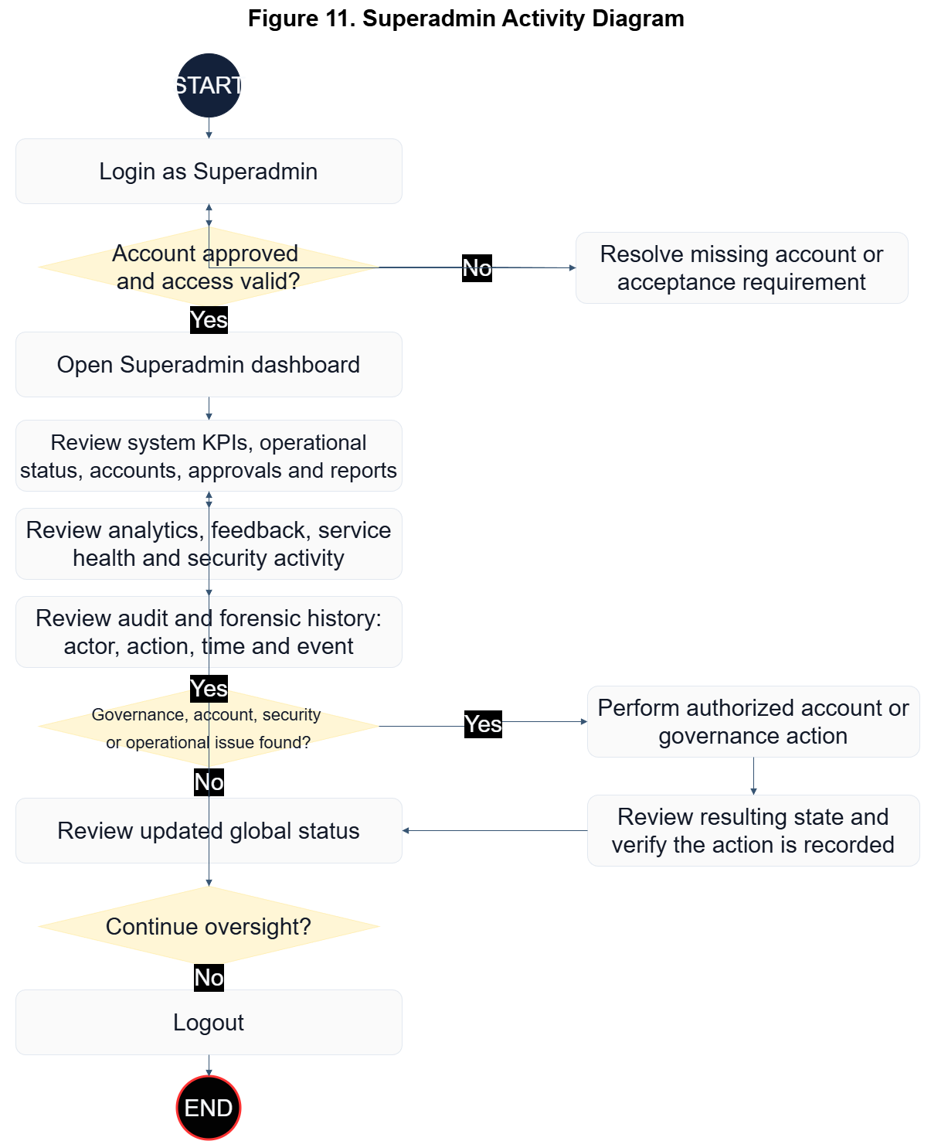
Figure 11. Superadmin Activity Diagram

Figure 11 describes the Superadmin workflow as a system-wide governance loop. After login and access-state validation, the superadmin reviews global KPIs, service health, user and role status, audit records, and governance conditions. When an issue is identified, the superadmin performs authorized user-management or governance actions within the system's predefined role-based access rules, validates the result, and continues oversight. The current implementation does not provide runtime editing of the role-permission policy.
Development
SENTINEL was developed through iterative Agile delivery in which user workflows, governance controls, and operational data services progressed in parallel.
The User Login Module serves as the secure authentication entry point of SENTINEL. It validates user credentials, enforces account and access controls, and directs authenticated users to the operational workspace permitted by their assigned role. The module also supports password recovery and ensures that only approved and active accounts can access protected system functions.
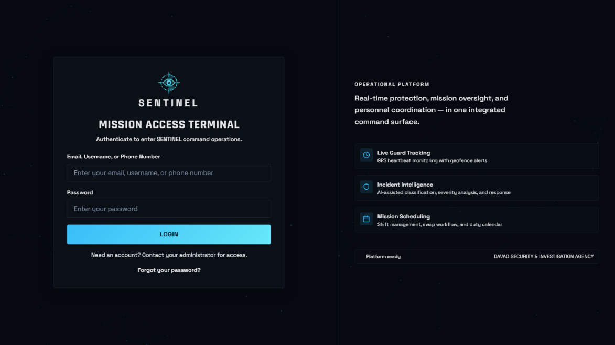
Figure 12. User Login Module

The Superadmin Module serves as the system-wide governance and monitoring workspace of SENTINEL. It provides access to global operational information, analytics, feedback, audit records, reports, service status, and other command-level functions required for overall system oversight. The Superadmin can review platform activity and governance information while remaining subject to the system’s predefined access-control rules.
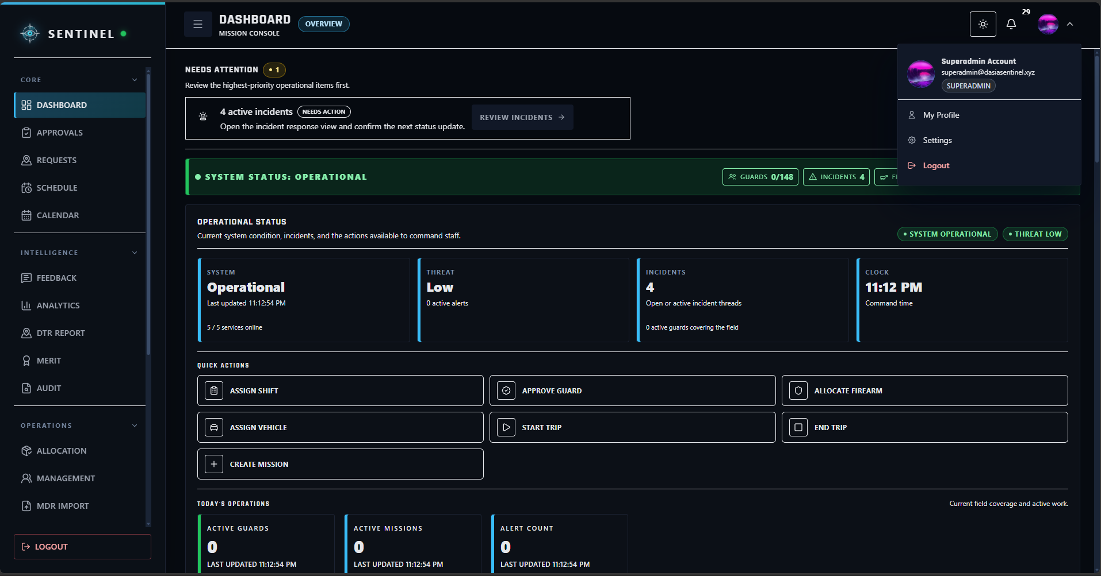
Figure 13. Superadmin Module

The Administrator Module serves as the primary management workspace for day-to-day administrative operations. Administrators can manage users, approvals, schedules, client sites, personnel records, firearms, armored vehicles, permits, and other authorized operational information while monitoring the continuity of agency operations.
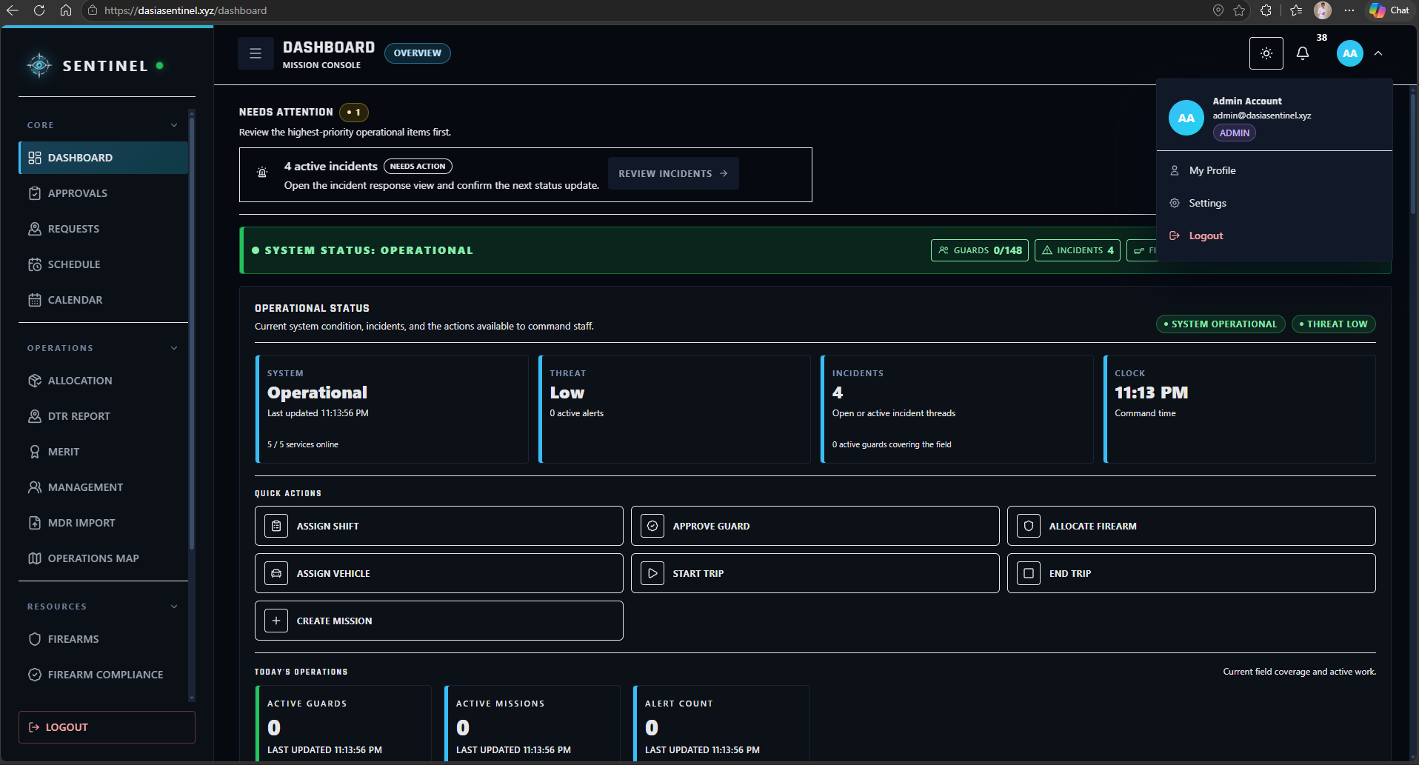
Figure 14. Administrator Module

The Supervisor Module serves as the field-supervision workspace for workforce and deployment coordination. Supervisors can monitor schedules, attendance, Guard availability, replacement activity, field conditions, incidents, and authorized operational resources to help maintain continuous duty coverage and respond to staffing concerns.
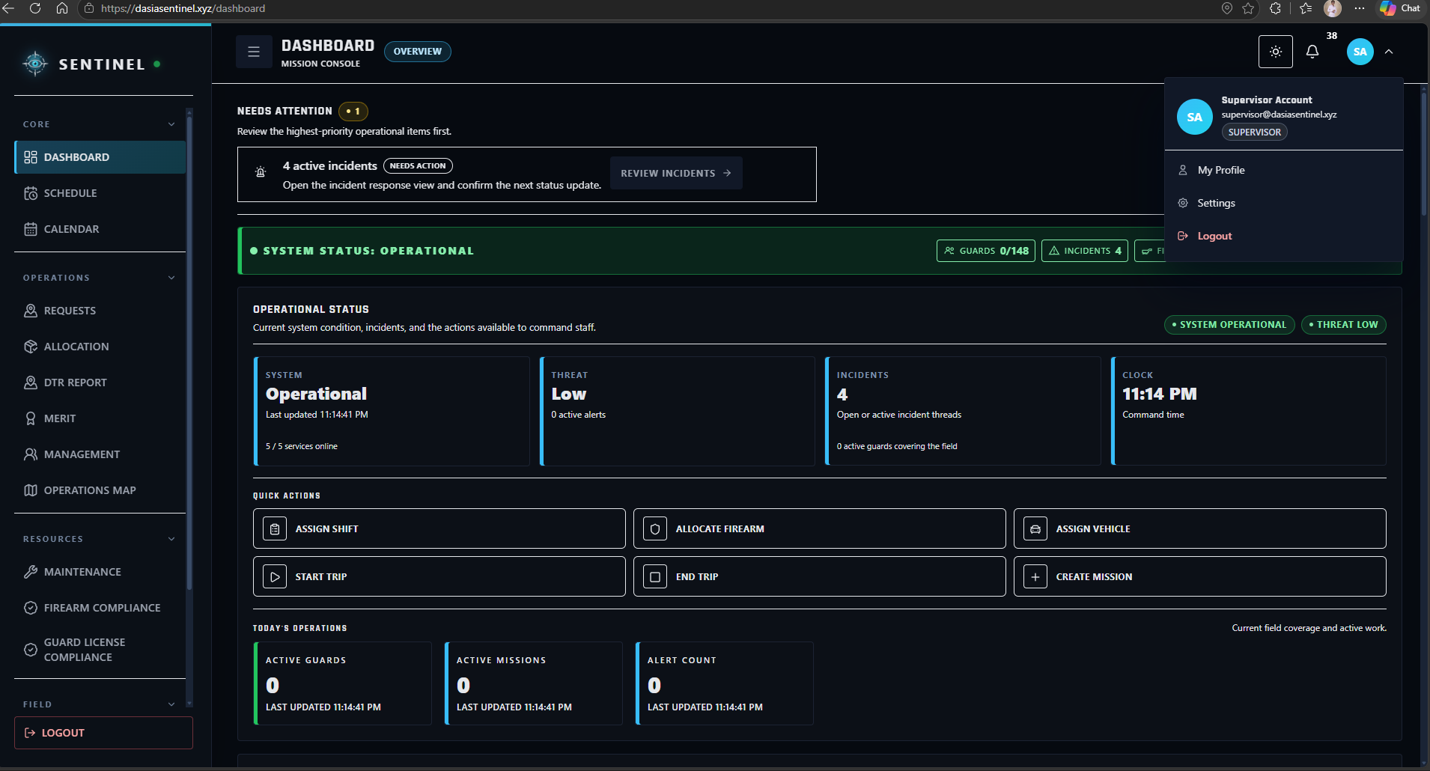
Figure 15. Supervisor Module

The Guard Module serves as the field-user workspace for assigned duty operations. Guards can review their schedules and assignments, perform attendance-related actions, receive operational notifications, submit incidents and support concerns, access authorized map and tracking functions, and use emergency features during active duty.
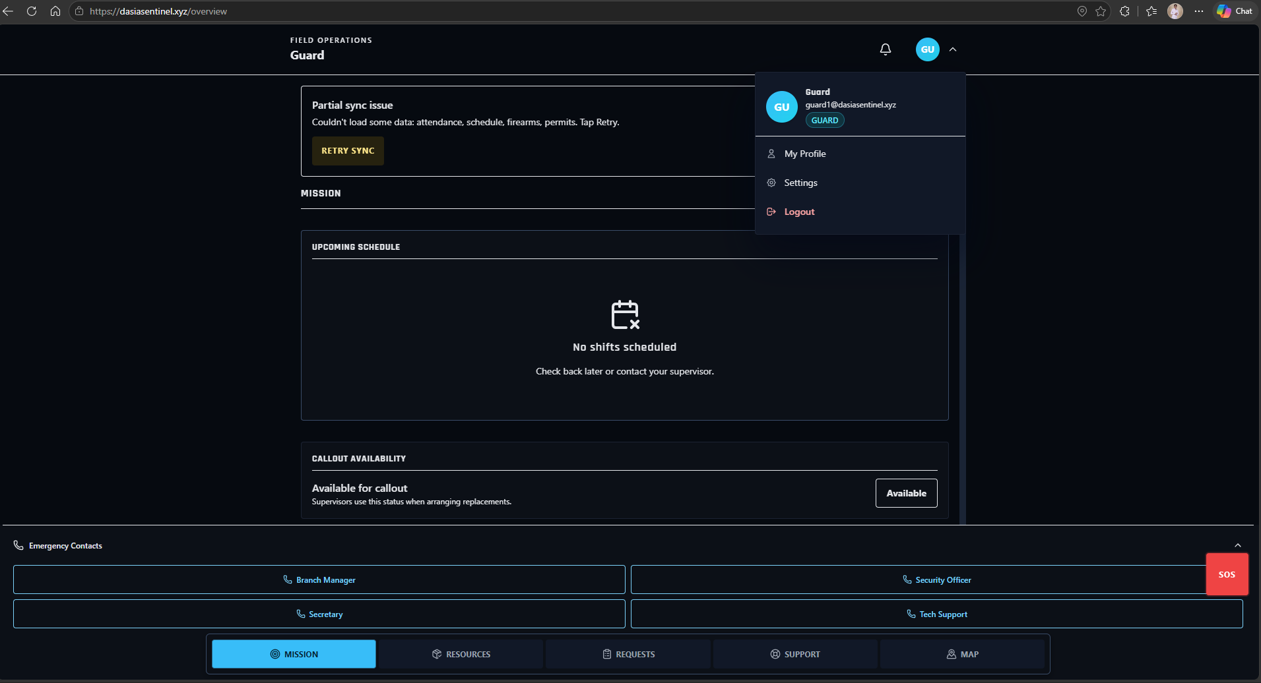
Figure 16. Guard Module

The Approvals Module serves as the controlled authorization workspace for account and access requests that require administrative review. Authorized users can review pending Guard registrations and approve or reject requests before operational access is granted, helping maintain controlled onboarding and account governance.
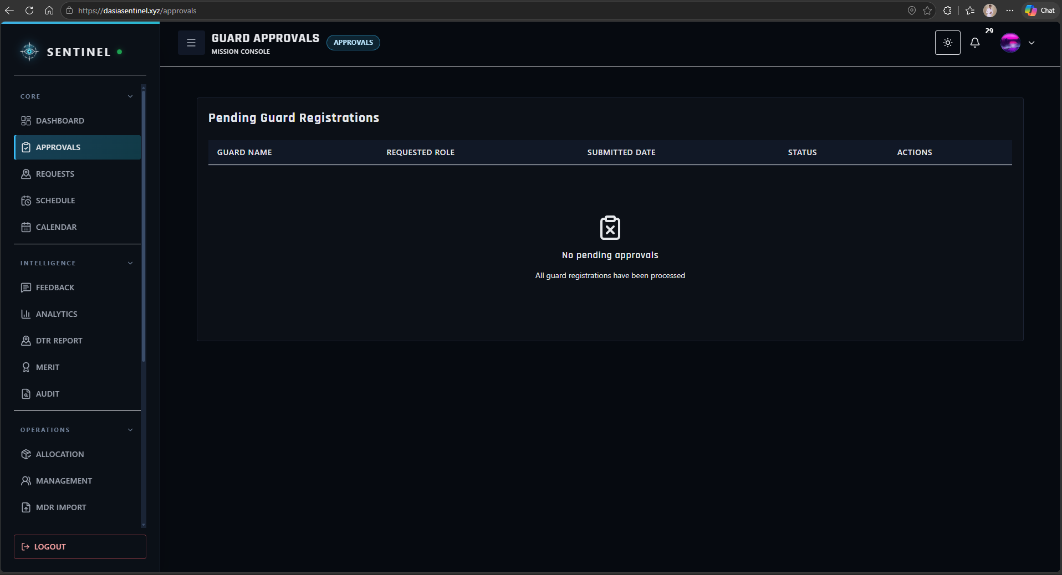
Figure 17. Approvals Module
The Scheduling module recorded each Guard’s client site, date, and duty period. Authorized users could create and review assignments, while the scheduling checks identified conflicting assignments and insufficient rest before reassignment.
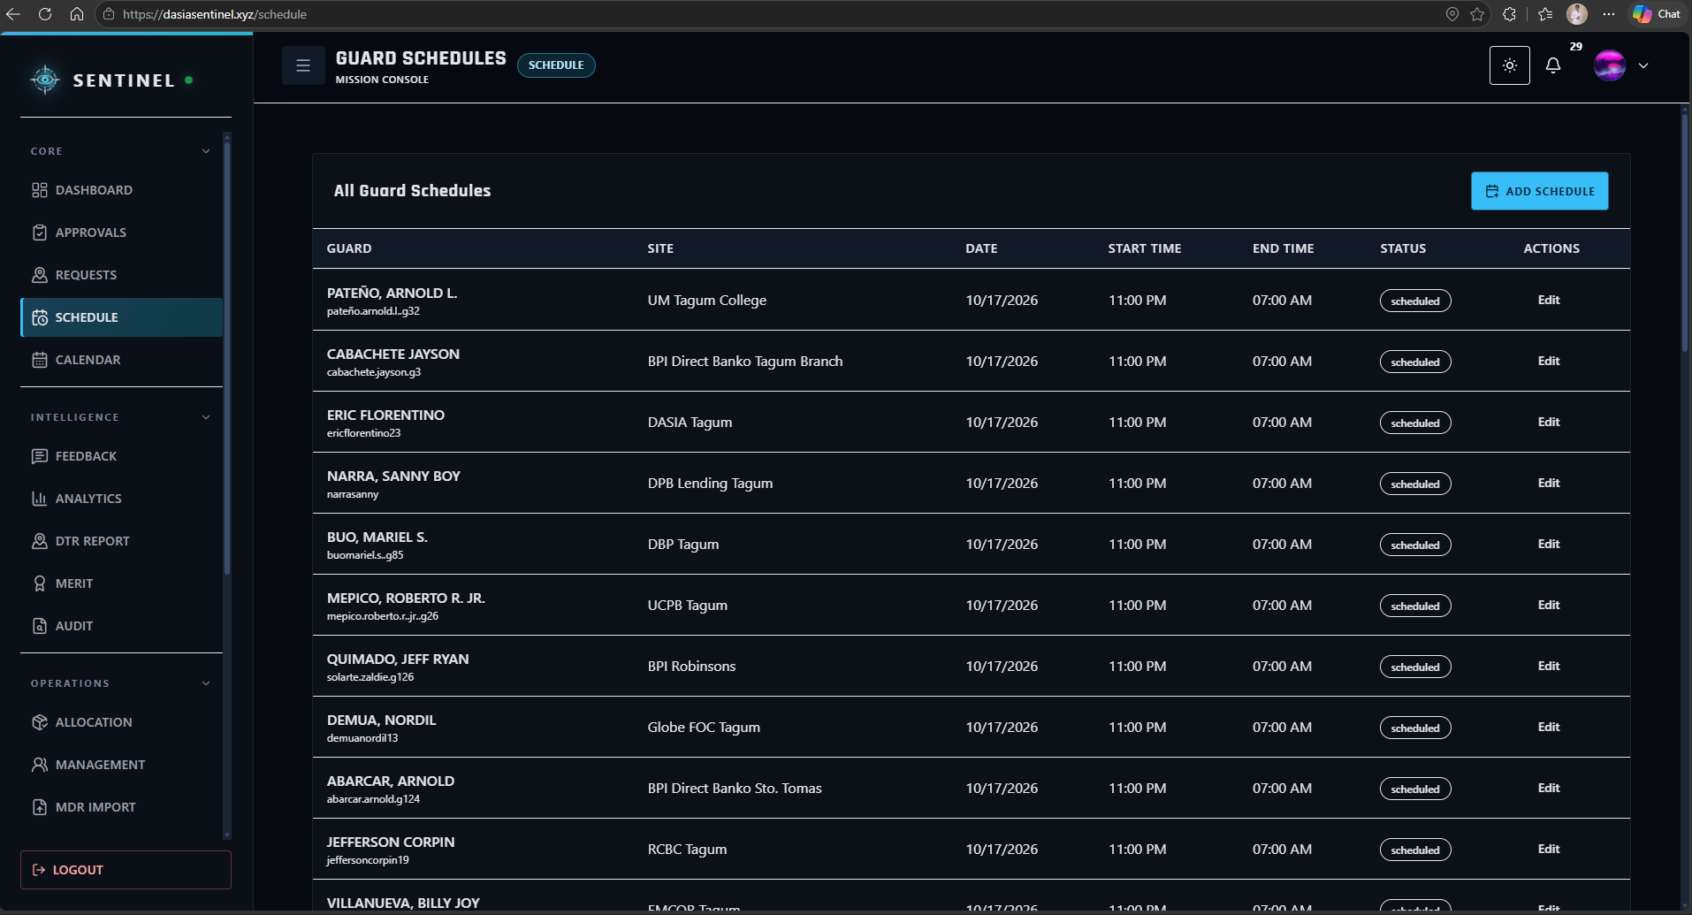
Figure 18. Scheduling Module

The Calendar Module provides a timeline-based view of Guard assignments and operational activities. It allows authorized users to review schedule distribution by date and helps improve visibility of upcoming duties, staffing coverage, and potential assignment conflicts.
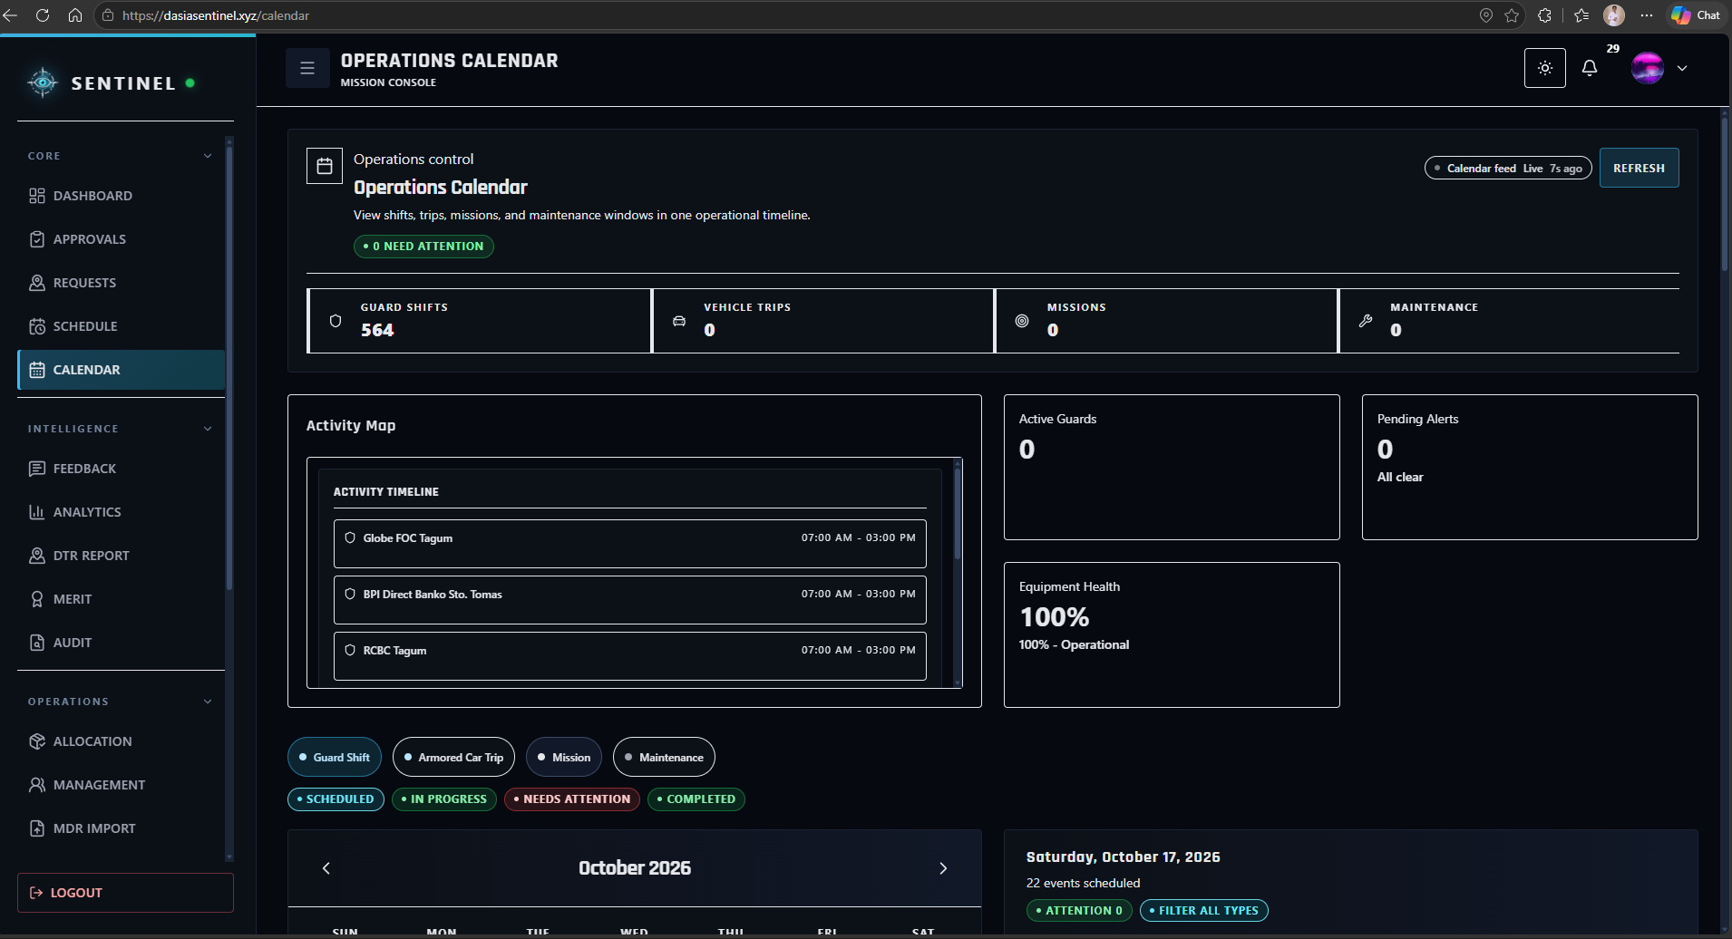
Figure 19. Calendar Module

The Operations Map Module serves as the geospatial monitoring workspace of SENTINEL. Authorized users can review client-site locations, deployment context, Guard-related location information, and available operational map data to support situational awareness and field coordination.
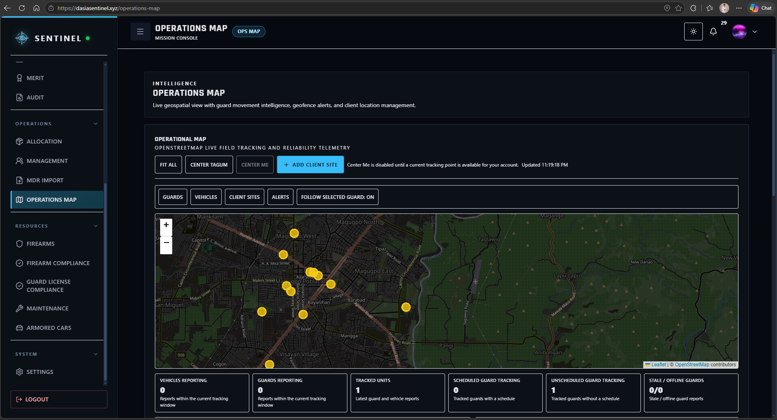
Figure 20. Operations Map Module

The Management Module serves as the centralized records workspace for authorized organizational resources. Depending on the user role, it provides access to personnel, firearms, vehicles, client sites, and other management records required for maintaining accurate operational information and administrative control.
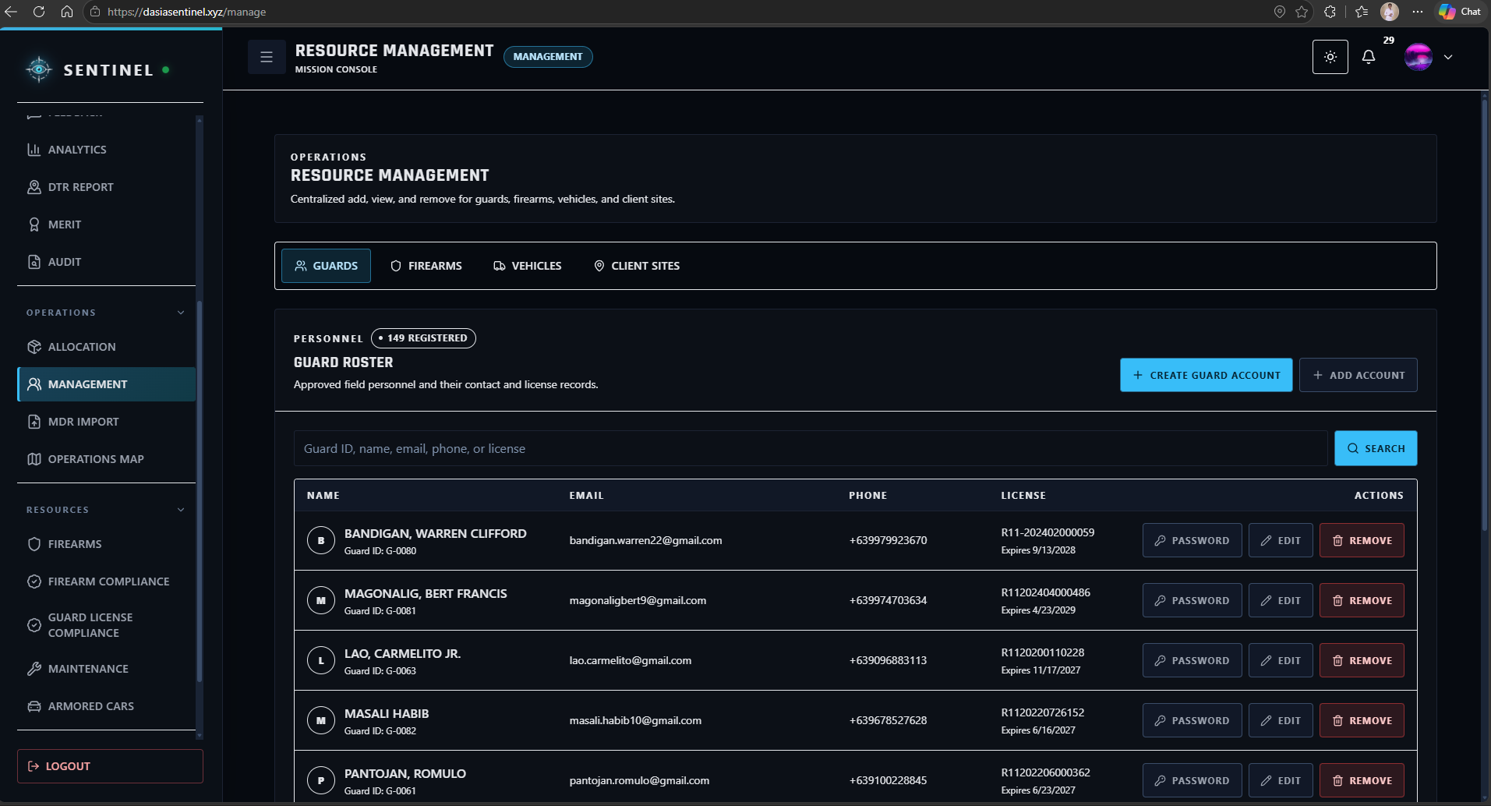
Figure 21. Management Module

The MDR Import Module serves as the controlled data-migration and cleansing workspace for existing DASIA records. It allows authorized users to upload structured Excel or MDR files, review imported data, identify inconsistent or incomplete entries, and prepare validated records for integration into SENTINEL. The feature reduces repetitive manual encoding and supports the transition of existing agency records into the centralized database.
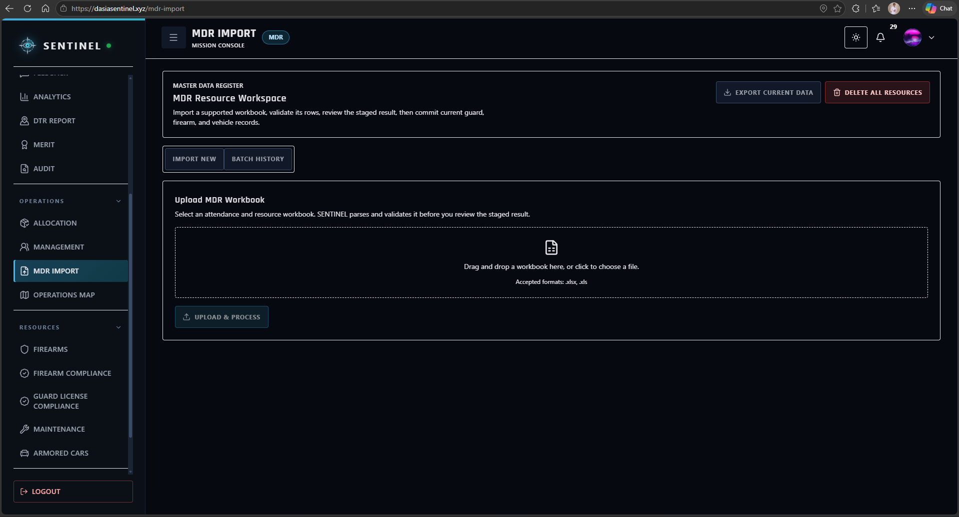
Figure 22. MDR Import Module

The Missions Module serves as the operational coordination workspace for mission-related assignments and activities. Authorized users can create and manage mission information, assign relevant personnel and resources, and monitor records associated with planned or ongoing operational activities.
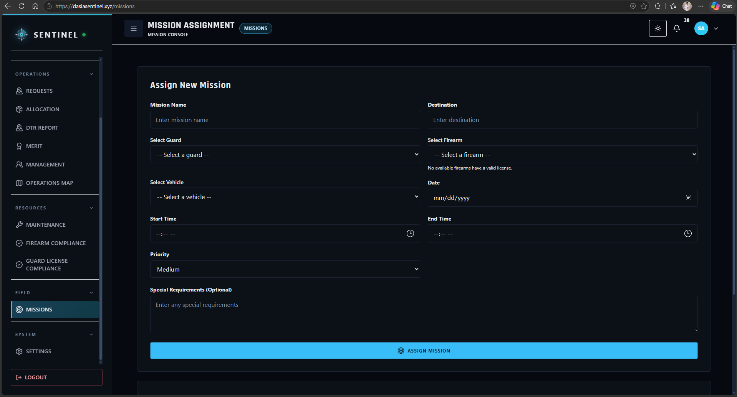
Figure 23. Missions Module
The Trips Module serves as the lifecycle monitoring workspace for authorized field and transport activities. It allows users to record and review trip information associated with operational movement, assigned personnel, vehicles, and other deployment-related details.
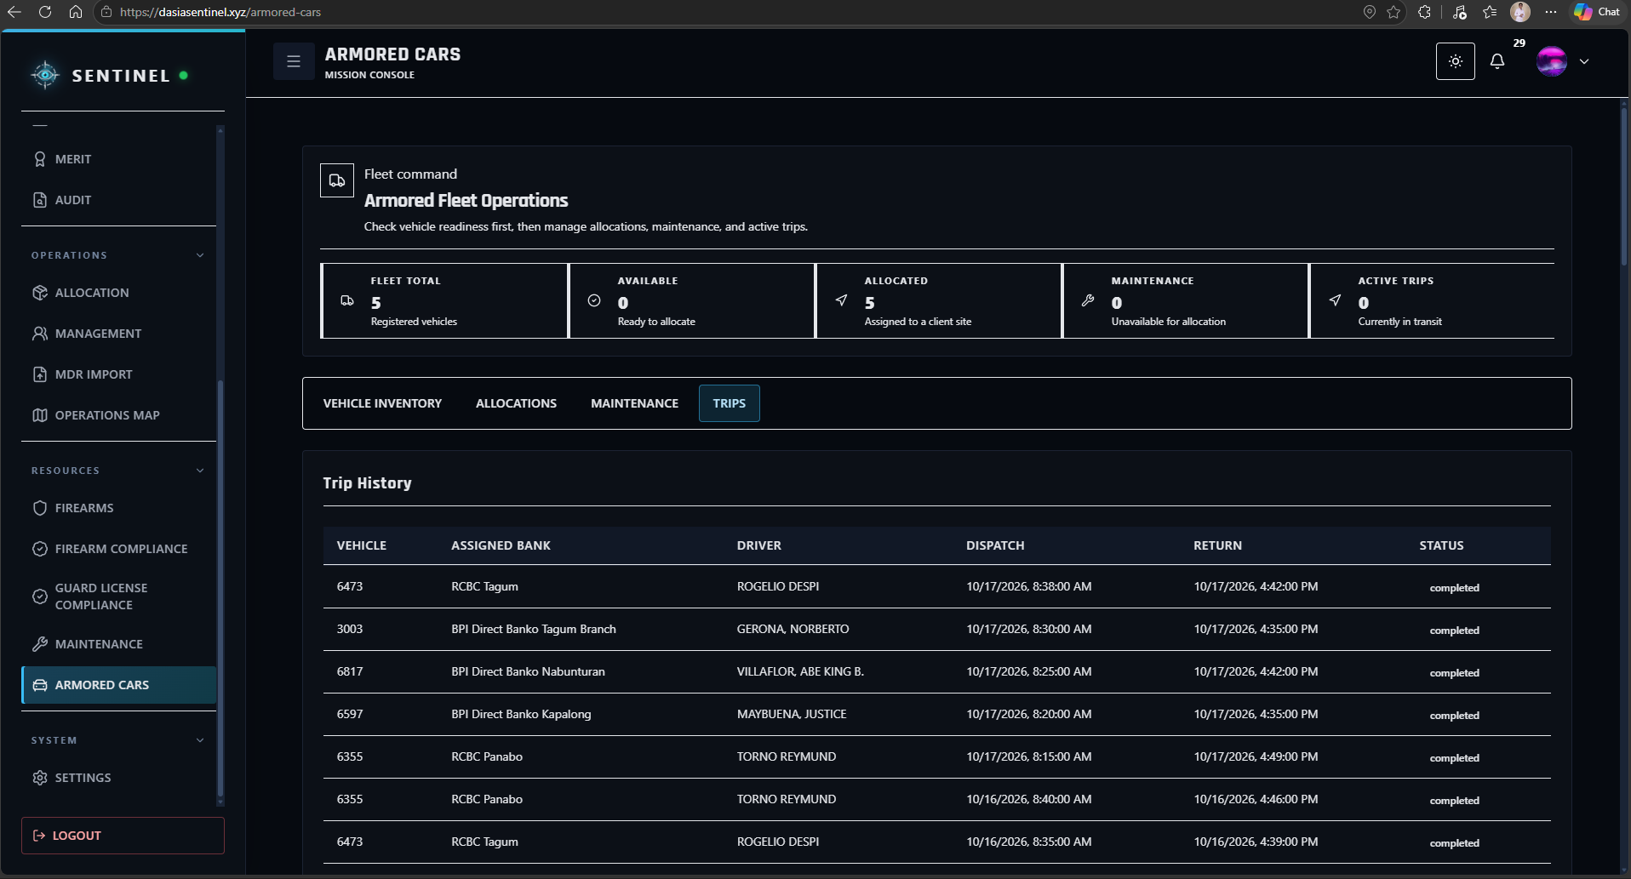
Figure 24. Trips Module
The Inbox Module serves as the centralized communication and quick-action workspace for operational messages and pending activities. It allows users to review notifications, requests, alerts, workflow updates, and other items requiring attention from a single interface.
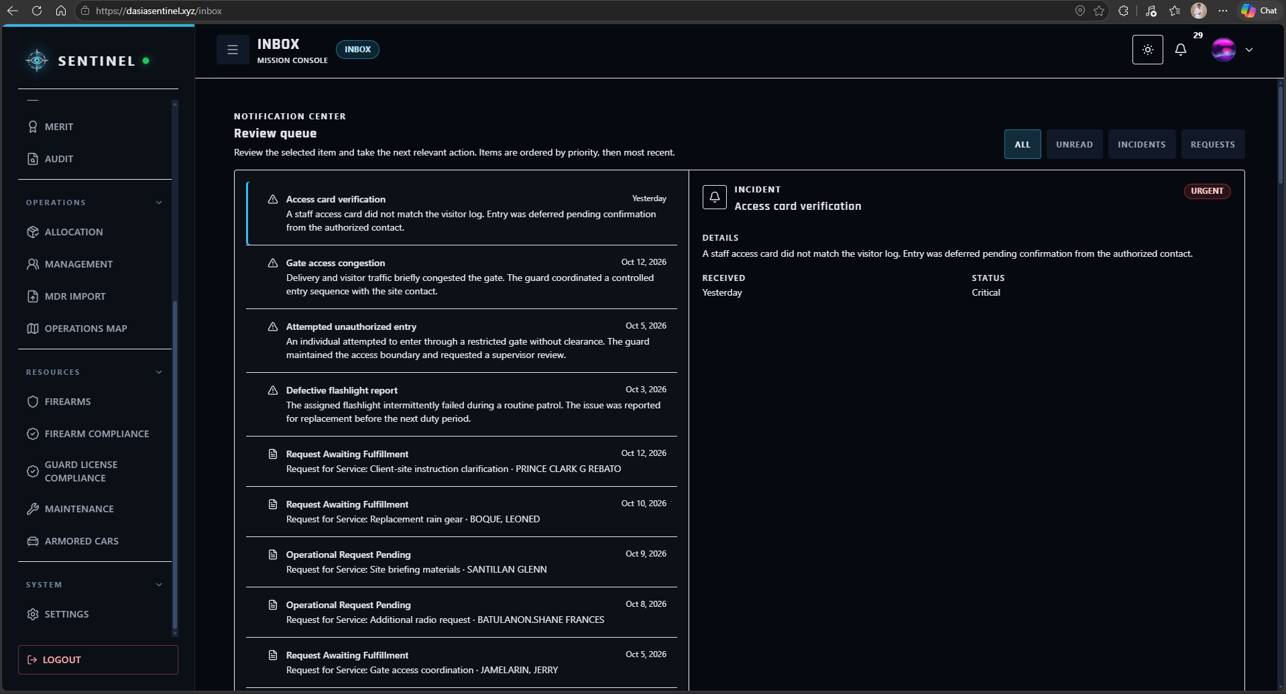
Figure 25. Inbox Module
The Support Module serves as the internal assistance channel for operational and system-related concerns. Users can submit support tickets, describe encountered issues, and review the status of their submitted requests until the concern is addressed or resolved.
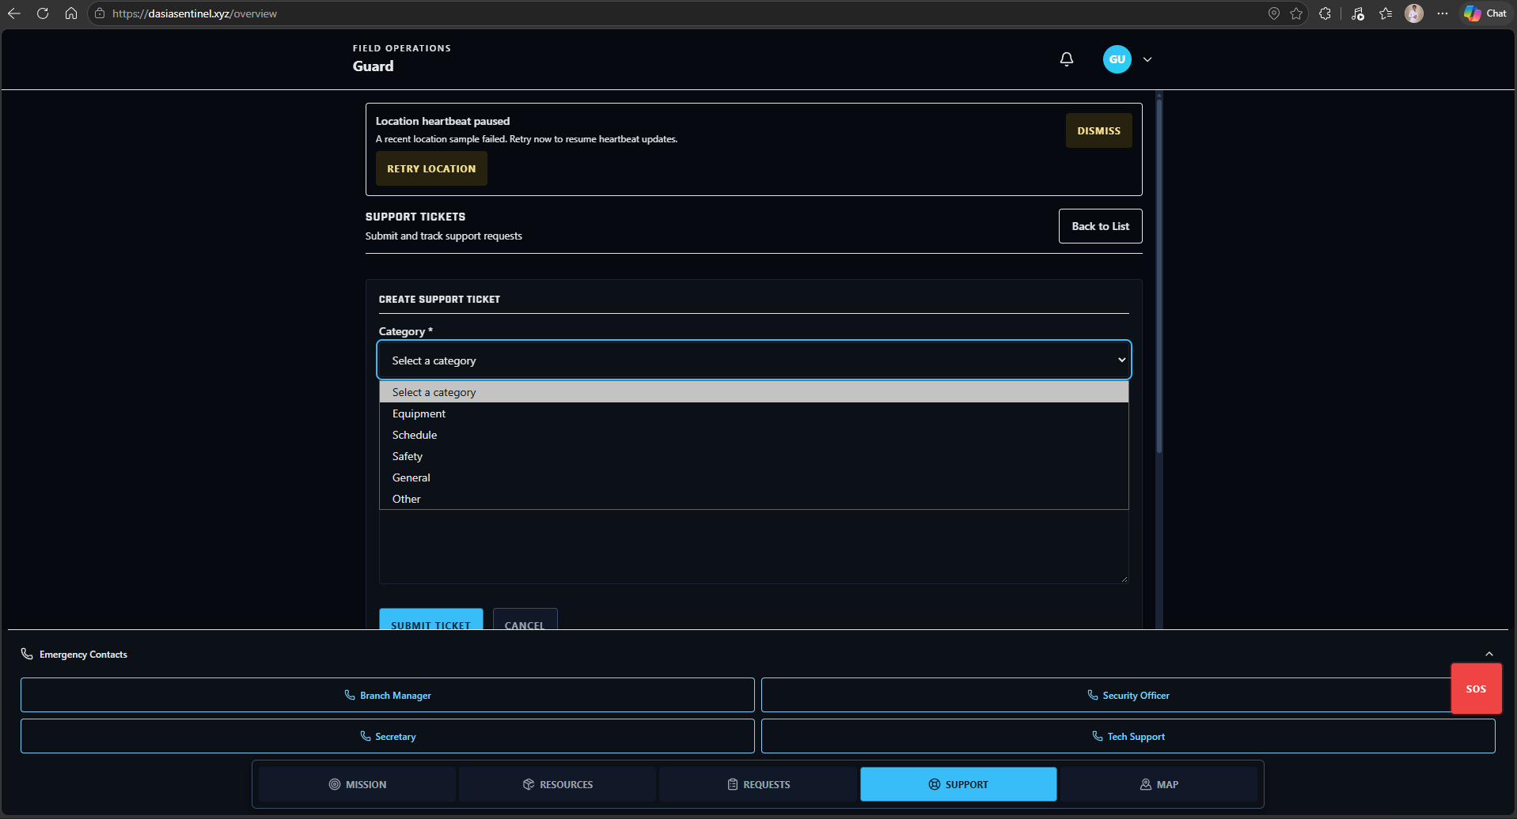
Figure 26. Support Module
The Feedback Submission Module provides users with a structured channel for submitting comments, ratings, concerns, and suggestions about their experience using SENTINEL. The collected feedback supports evaluation and continued refinement of the system.
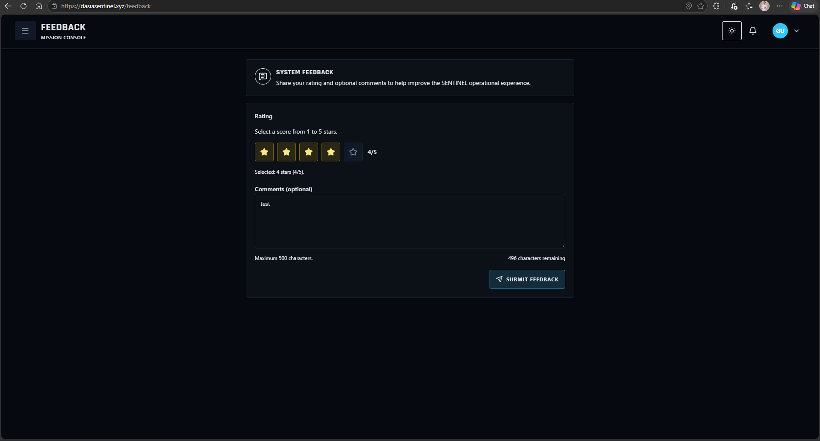
Figure 27. Feedback Submission Module
The Feedback Dashboard Module provides authorized command users with a consolidated view of submitted user feedback. It allows feedback records and ratings to be reviewed to identify recurring concerns, positive experiences, and areas that may require further system improvement.
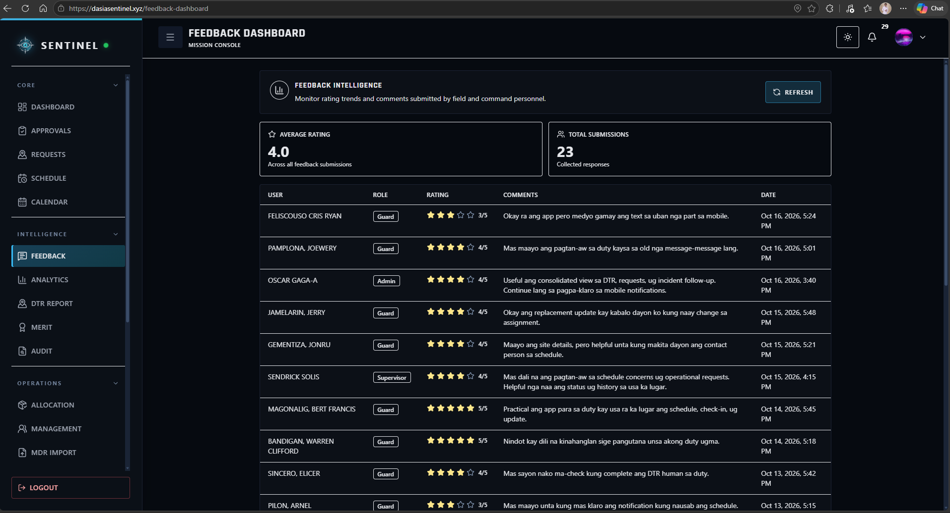
Figure 28. Feedback Dashboard Module
The Firearms Module serves as the centralized inventory workspace for agency firearms. Authorized users can review firearm records, serial information, status, condition, availability, and other information required for controlled asset monitoring.
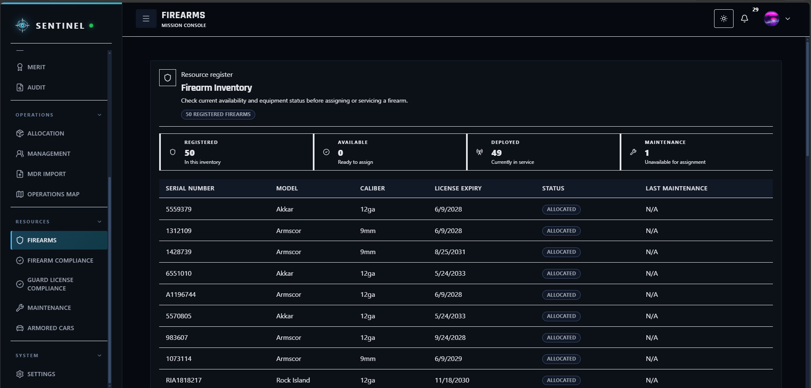
Figure 29. Firearms Module
The Firearms Allocation module linked each issuance to a Guard and firearm record. It recorded issue and return information and showed the custody status so authorized users could review firearms that remained issued or had been returned.
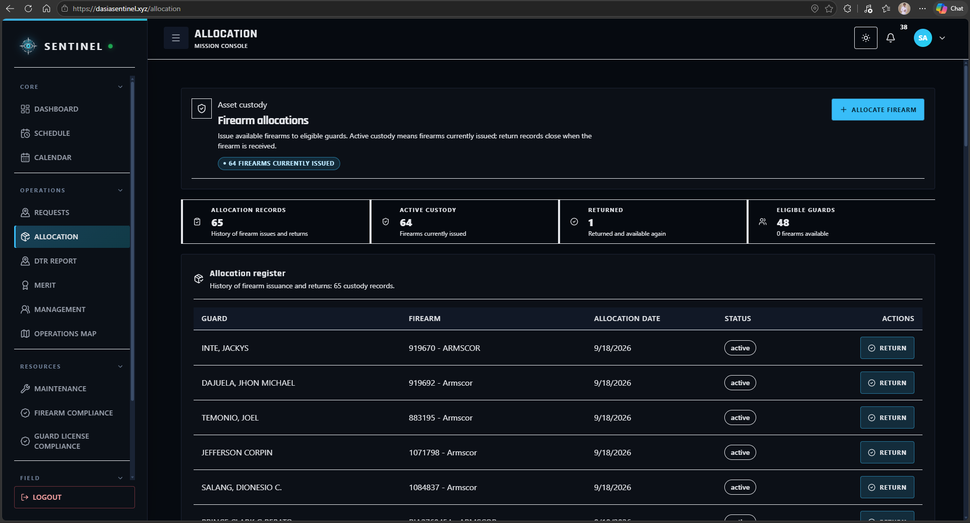
Figure 30. Firearms Allocation Module

The Firearms Permits Module serves as the compliance-monitoring workspace for firearm-related permits and documentation. Authorized users can review permit validity, expiration information, and related records to support compliance and prevent the operational use of assets with invalid documentation.
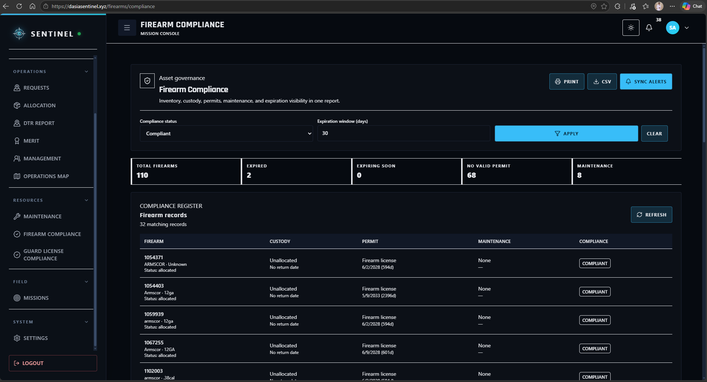
Figure 31. Firearms Permits Module

The Armored Cars module stored vehicle records and linked them to allocations and trip entries. Authorized users could review vehicle status and the recorded trip history.
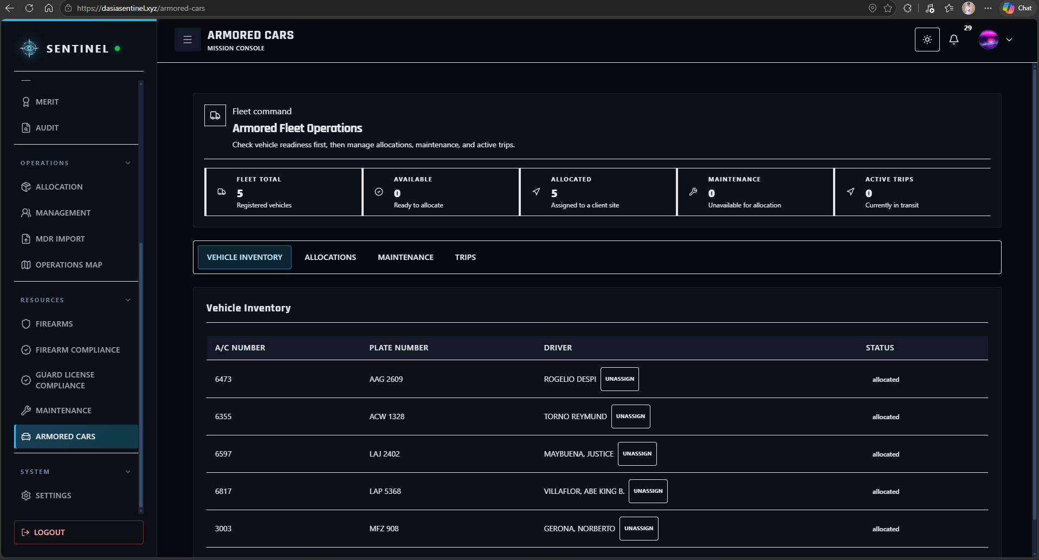
Figure 32. Armored Cars Module

The Maintenance Module provides authorized users with a workspace for monitoring maintenance activities involving operational assets. It supports the recording and review of maintenance schedules, service status, and maintenance history to help maintain asset readiness and reduce unexpected downtime.
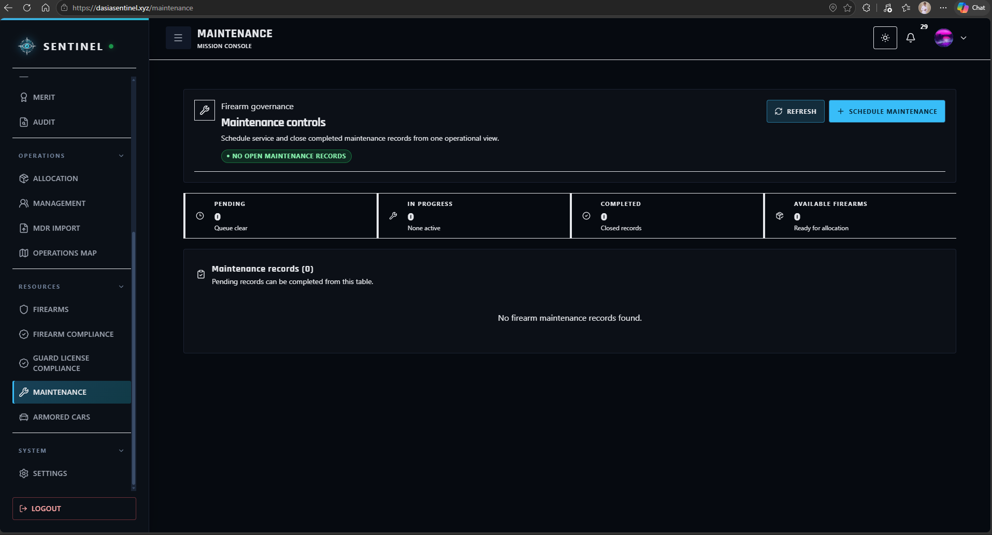
Figure 33. Maintenance Module
The Analytics module displayed summaries derived from attendance, lateness, assignments, incidents, and Guard-performance records. Authorized command users could filter and review those indicators in the dashboard.
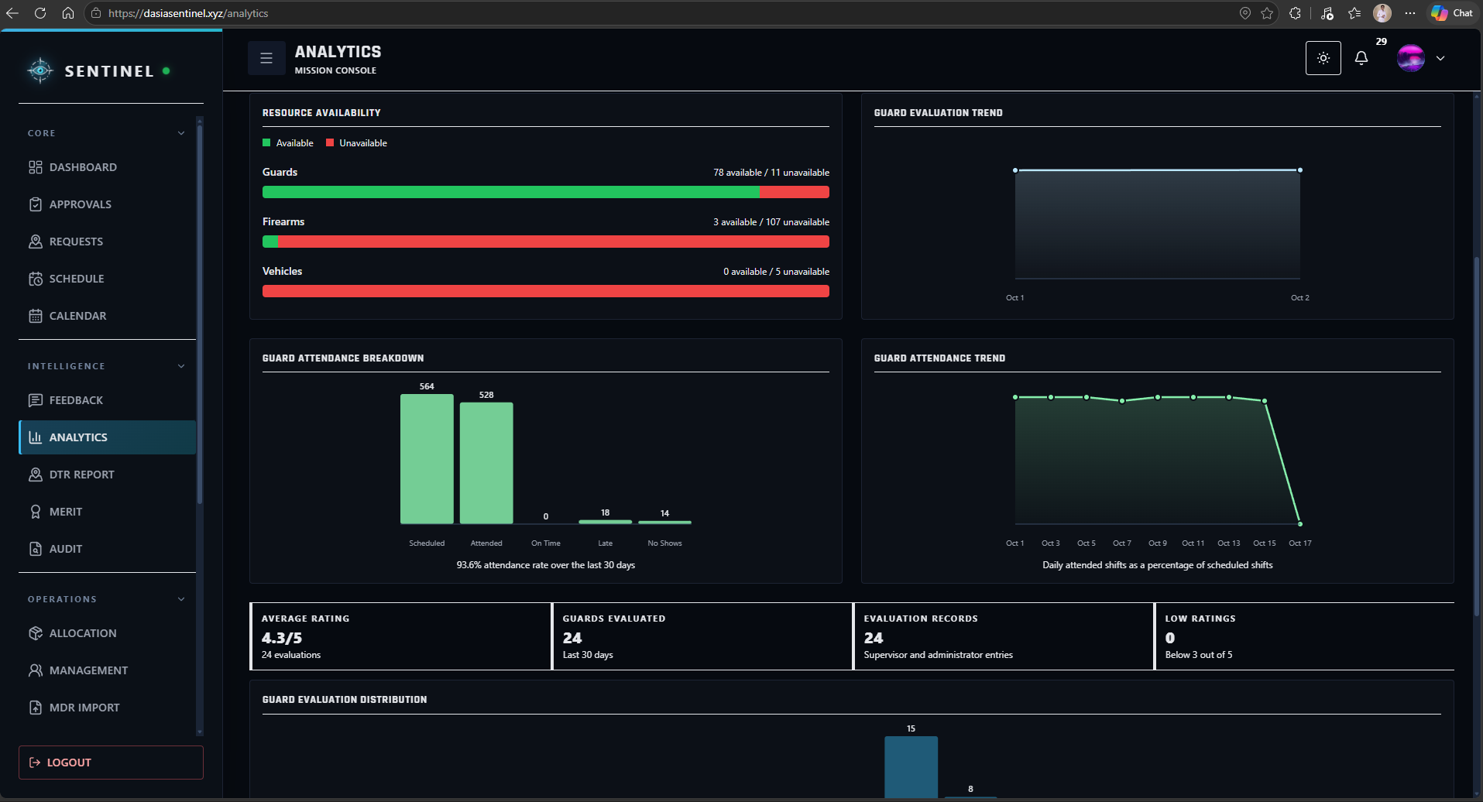
Figure 34. Analytics Module

The Audit module displayed recorded actions with their actor, action, timestamp, and related record information. Authorized users could filter these entries when reviewing account and operational changes.
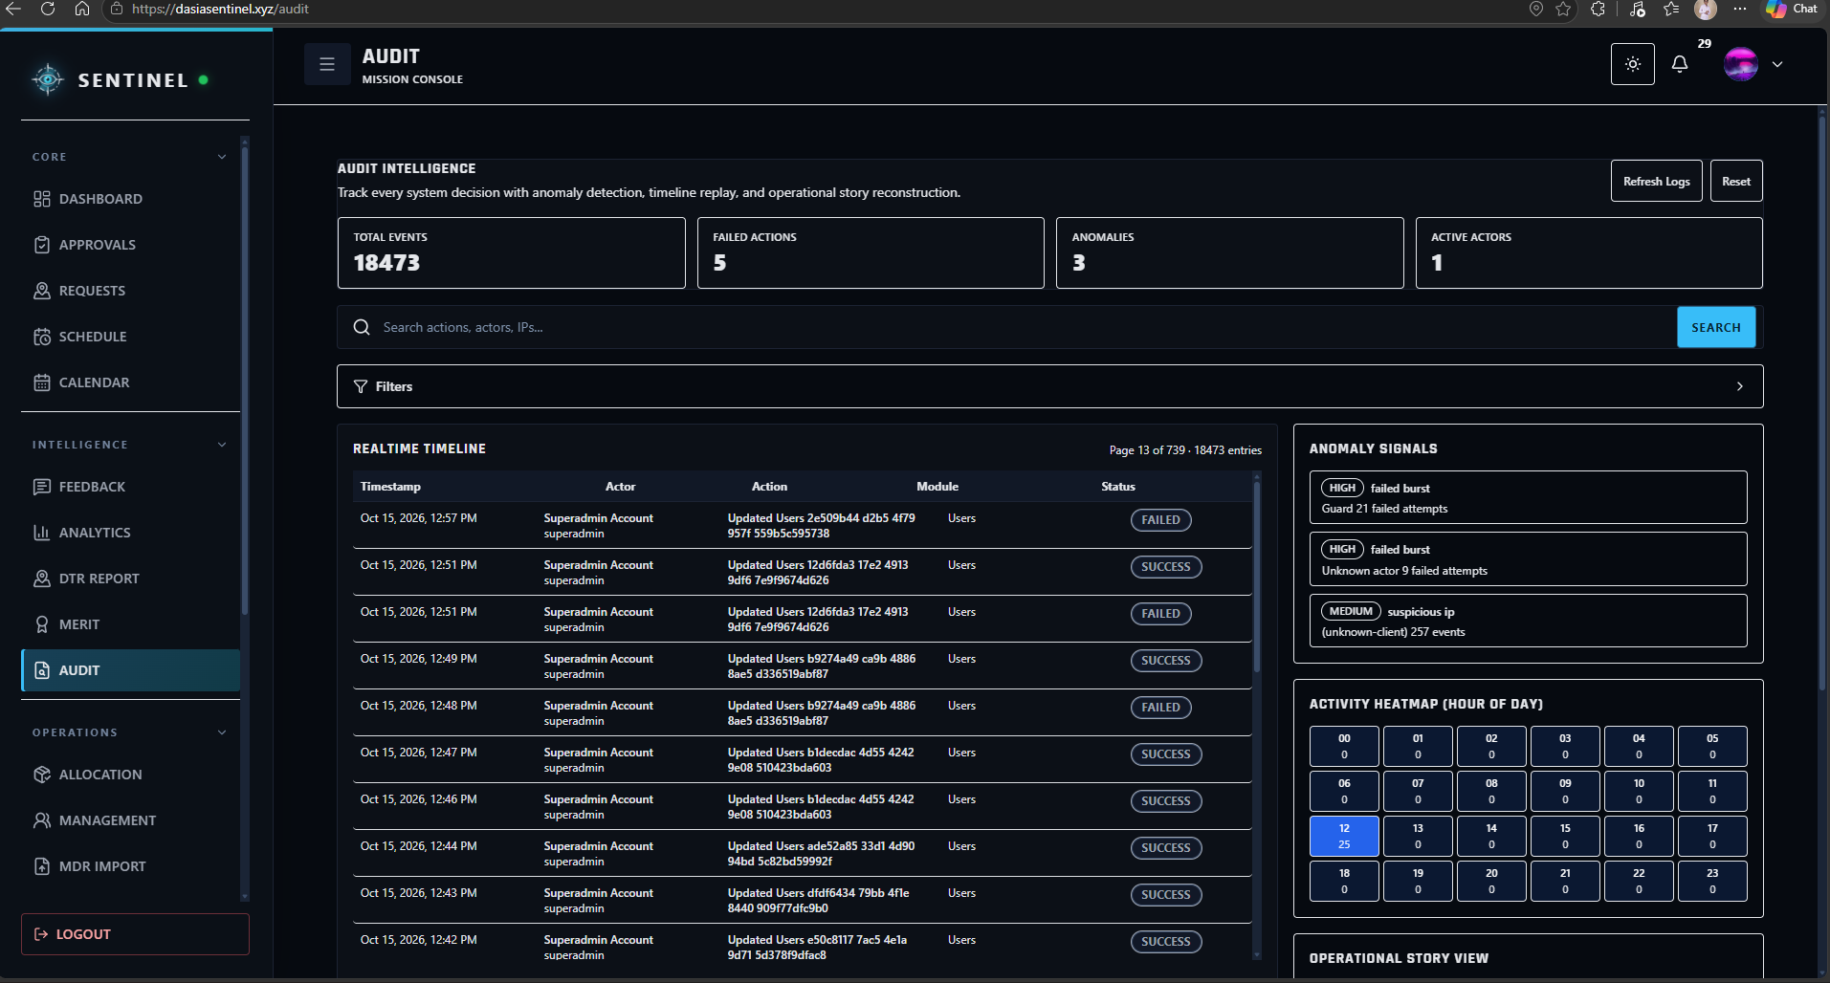
Figure 35. Audit Module
The Profile Module provides users with access to their account and identity information. Users can review and update permitted profile details while remaining subject to the access and security restrictions associated with their assigned role.
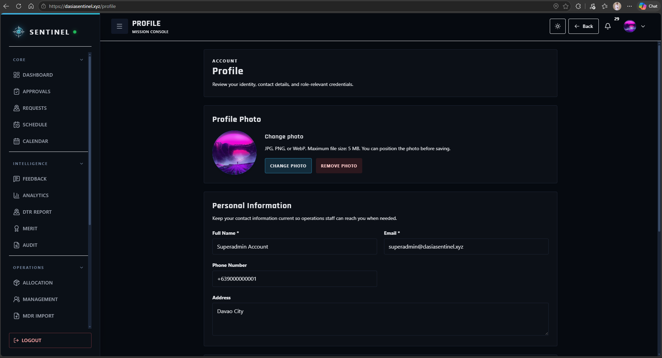
Figure 36. Profile Module
The Settings Module serves as the configuration workspace for available user and system preferences. Authorized users can manage applicable notification and interface settings according to the controls permitted for their role.
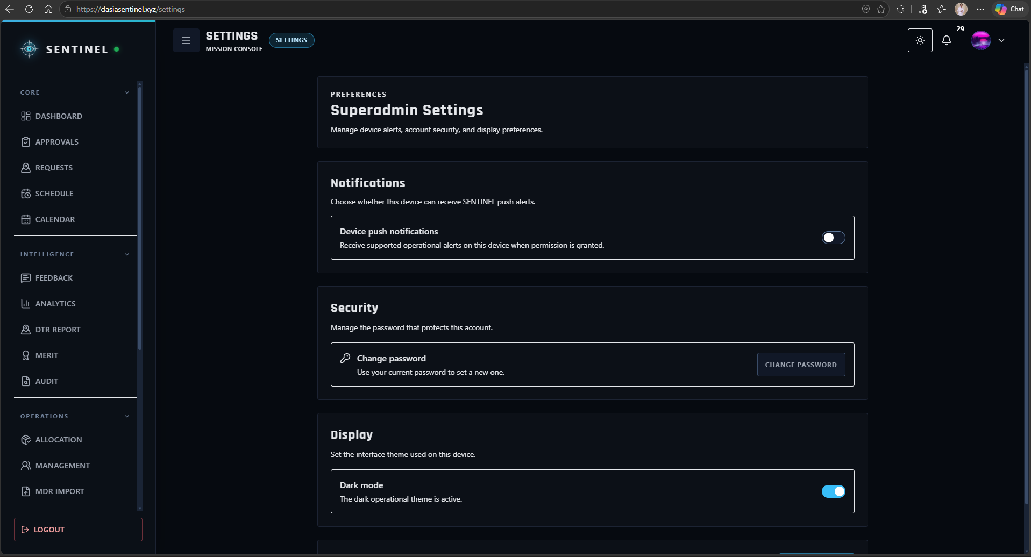
Figure 37. Settings Module

RESULTS AND DISCUSSION

Testing
SENTINEL underwent build, automated, browser-workflow, and record-consistency testing. The frontend passed TypeScript checking, its production build, and 202 Jest tests across 57 suites. The backend passed 60 tests; seven record-consistency tests and 16 selected Playwright browser checks also passed. The final checks detected no overlapping Guard shifts, insufficient-rest violations, firearm-custody overlaps, invalid custody chronology, or overlapping vehicle trips in the records examined. The hosted frontend and backend health endpoints returned HTTP 200 during the final availability check. The Windows desktop and Android applications also completed installation and runtime testing on their intended platforms.

Description of Prototype
SENTINEL was developed as a role-governed security operations system for Davao Security & Investigation Agency, Inc. It combined access management, Guard records, scheduling, attendance and DTR, replacement, incidents, requests, notifications, location monitoring, firearm custody, vehicle trips, analytics, feedback, and audit information in a shared database. The four main roles were Guard, Supervisor, Administrator, and Superadmin.
Guards accessed schedules, attendance, notifications, field reporting, and authorized location functions. Supervisors coordinated staffing, replacements, incidents, requests, and permitted operational resources. Administrators handled approvals, personnel, schedules, sites, assets, and compliance records. Superadmins reviewed system-wide dashboards, reports, and audit information. The Web application ran at dasiasentinel.xyz using React, TypeScript, Vite, Rust, Axum, and PostgreSQL on hosted services. The Web application served as SENTINEL’s primary runtime. The Windows desktop application through Tauri and the Android application through Capacitor were installed and successfully tested on their intended platforms.

Implementation Plan
The on-site implementation orientation of SENTINEL was conducted on September 28, 2026, at approximately 7:00 a.m. at Davao Security & Investigation Agency, Inc. in Tagum City. A project representative met with the agency manager and the Security Officer to introduce the deployed SENTINEL system, demonstrate its operational workflows, and explain how the system could be used for security personnel coordination, asset accountability, operational monitoring, and administrative review.
The demonstration began with secure login and role-governed access. The manager and Security Officer were shown how authorized users accessed the system dashboard and how permissions separated Guard, Supervisor, Administrator, and Superadmin functions. The demonstration then covered Guard records, client-site assignments, duty schedules, attendance monitoring, Daily Time Records, absence detection, and replacement coordination. These functions showed how personnel assignments and staffing concerns could be reviewed through centralized records rather than through separate manual logs and phone-based coordination.
The asset-accountability workflow was also demonstrated through firearm inventory, firearm allocation, issuance-and-return custody records, permit and compliance information, armored-vehicle records, trip monitoring, and maintenance information. The demonstration explained how the system recorded the assigned Guard, controlled asset, transaction date and time, return status, and related compliance information to support traceability.
For field and command operations, the demonstration covered incident reporting, operational requests, notifications, Inbox workflows, support tickets, location-monitoring functions, the Operations Map, analytics, performance indicators, reports, and audit logs. The manager and Security Officer were shown how these records could be reviewed by authorized personnel to identify staffing conditions, pending operational concerns, incident information, asset status, and recorded system actions.
After the demonstration, the manager and Security Officer raised follow-up questions regarding the system’s workflows and intended operational use. Each question was answered by returning to the relevant interface and explaining the required user role, information entered, approval or review action, and resulting system record. This process allowed the agency representatives to clarify how SENTINEL handled the transition from manual records to role-governed digital workflows.
The implementation required the hosted SENTINEL application, stable internet access, a desktop computer or mobile device with a supported browser, authorized user accounts, and prepared personnel and operational records. The Web application served as the main access channel. The Windows desktop and Android applications were also installed and successfully tested on their intended platforms.
During the implementation period, SENTINEL managed deployment records for 11 DASIA client sites. The schedules used Day, Evening, and Night duty periods, included Sunday coverage, checked Guard availability before replacement, and prevented reassignment when the required rest period was not met.

Implementation Results
The records examined contained 55 Guard profiles across 11 client-site rosters and 564 scheduled shifts. They included 528 completed attendance records: 510 marked on time and 18 marked late. Three shifts were marked absent, and three replacement assignments were completed. The consistency checks detected no overlapping Guard assignments or insufficient-rest violations in the checked records.
The records reviewed included seven incidents, nine requests with 22 history events, 23 notifications, 96 readiness checks, seven support tickets, 24 client evaluations, 55 merit scorecards, and tracking records. Four rule-based absence-risk scenarios were checked separately the validation checks covered interactions among these modules. The objective discussions below present implementation evidence alongside the corresponding quantitative evaluation results.
1. Secure Access and Approval-Governed User Management
The system implemented secure authentication, approval controls, account recovery, token-based sessions, policy acceptance, and role-governed access. Protected actions were restricted by Guard, Supervisor, Administrator, and Superadmin permissions. The completed questionnaires produced an objective mean of 4.85 (Strongly Agree). Figures 38 and 39 show the login and account-approval interfaces.
Figure 38 presents the SENTINEL login interface used by authorized personnel to access the system. The interface serves as the entry point for secure authentication and routes users to the workspace permitted by their assigned role.
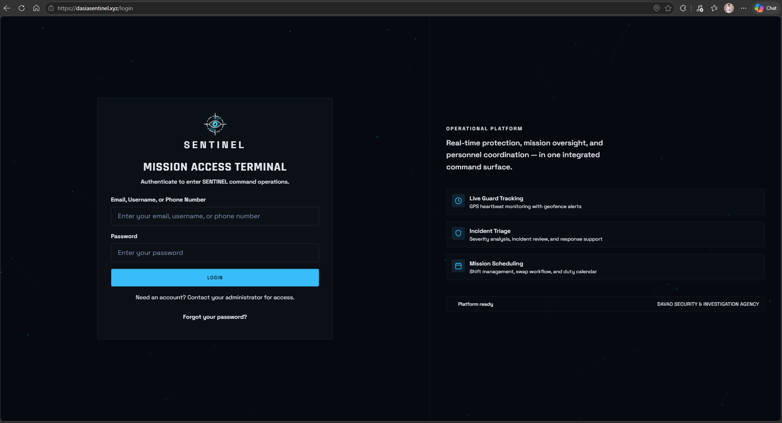
Figure 38. User Login and Secure Access Interface
Figure 39 presents the approval and user-management functions used to review account records, control access, and maintain role-governed user information. These functions support the first objective by keeping account onboarding and access decisions under authorized administrative control.
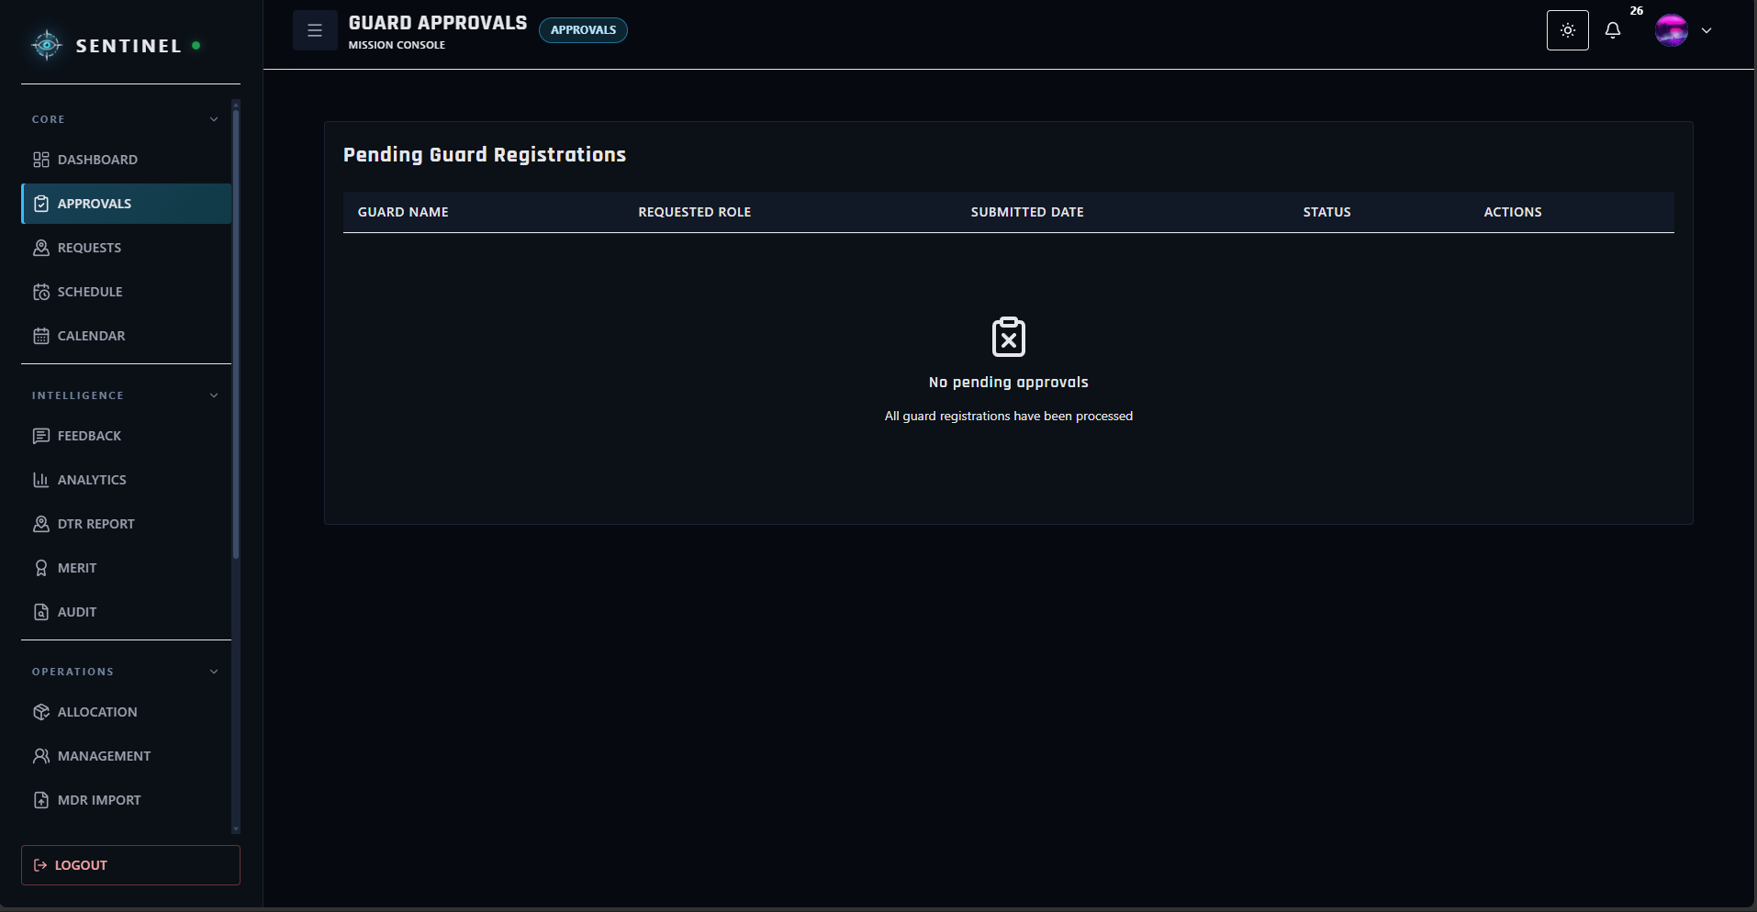
Figure 39. Approval and User Management Interface

Table 3. Quantitative Results for Secure and Approval-Governed Access
Assessment Description | Guard | Supervisor | Administrator | Superadmin | AWM | Equivalent
- Authentication, verification, approval, and recovery | 4.85 | 5.00 | 4.75 | 4.50 | 4.83 | Strongly Agree
- Role-governed access and account restrictions | 4.90 | 5.00 | 4.50 | 4.50 | 4.85 | Strongly Agree
- Session protection, revocation, and policy acceptance | 4.87 | 5.00 | 5.00 | 5.00 | 4.90 | Strongly Agree
Mean |  |  |  |  | 4.85 | Strongly Agree
2. Personnel Operations, Attendance, Scheduling, and Replacement
SENTINEL maintained Guard records, site assignments, schedules, attendance, DTR, no-show indicators, and replacement workflows. The records examined included 564 scheduled shifts, 528 completed attendance records, three recorded absences, and three completed replacements. Of the completed attendance records, 510 were on time and 18 were late. No shift overlap or insufficient-rest violation was detected in the final checks. The respondents’ mean rating for personnel operations was 4.82 (Strongly Agree). Figures 40–42 show scheduling, attendance, and replacement.
Figure 40 presents the scheduling interface used to manage Guard duty assignments across client sites and rotating shifts. The schedule provides command users with a centralized view of personnel coverage and assigned duty periods.
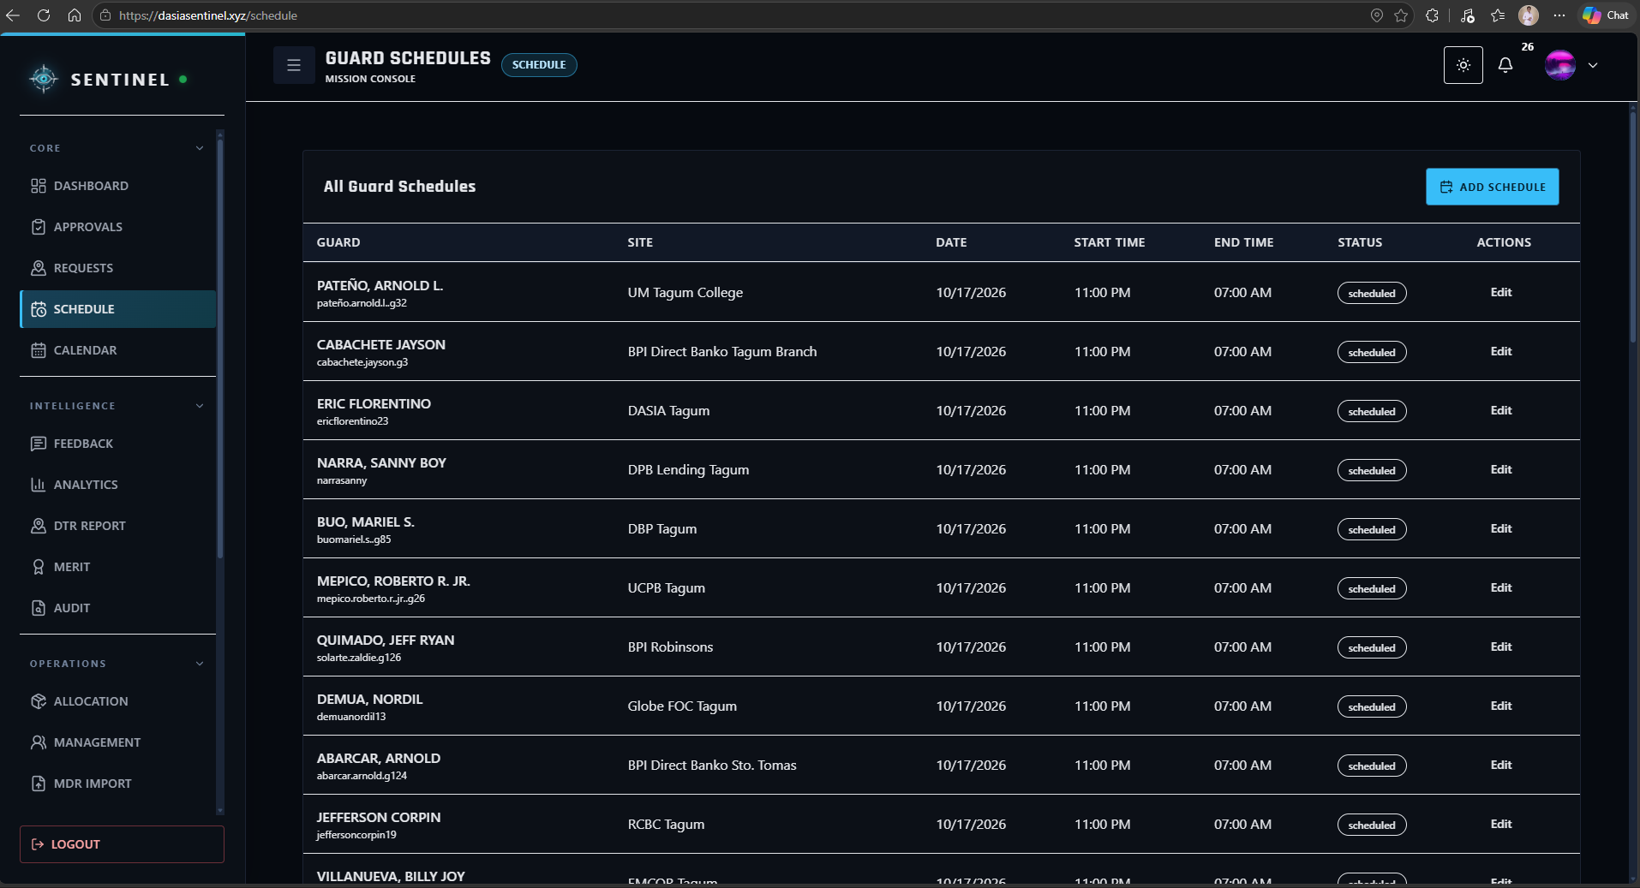
Figure 40. Guard Scheduling Interface

Figure 41 presents the attendance and Daily Time Record interface, where authorized users can review scheduled duty, actual check-in and check-out records, late information, rendered duty hours, and attendance status.
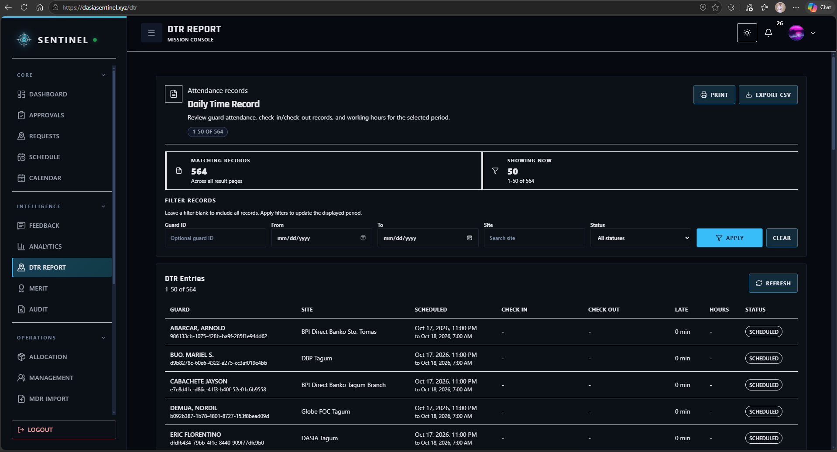
Figure 41. Attendance and DTR Interface

Figure 42 presents the Guard replacement workflow used when a scheduled Guard becomes unavailable or is recorded absent. The interface supports the review of eligible replacements and confirmed reassignment while preserving shift continuity.
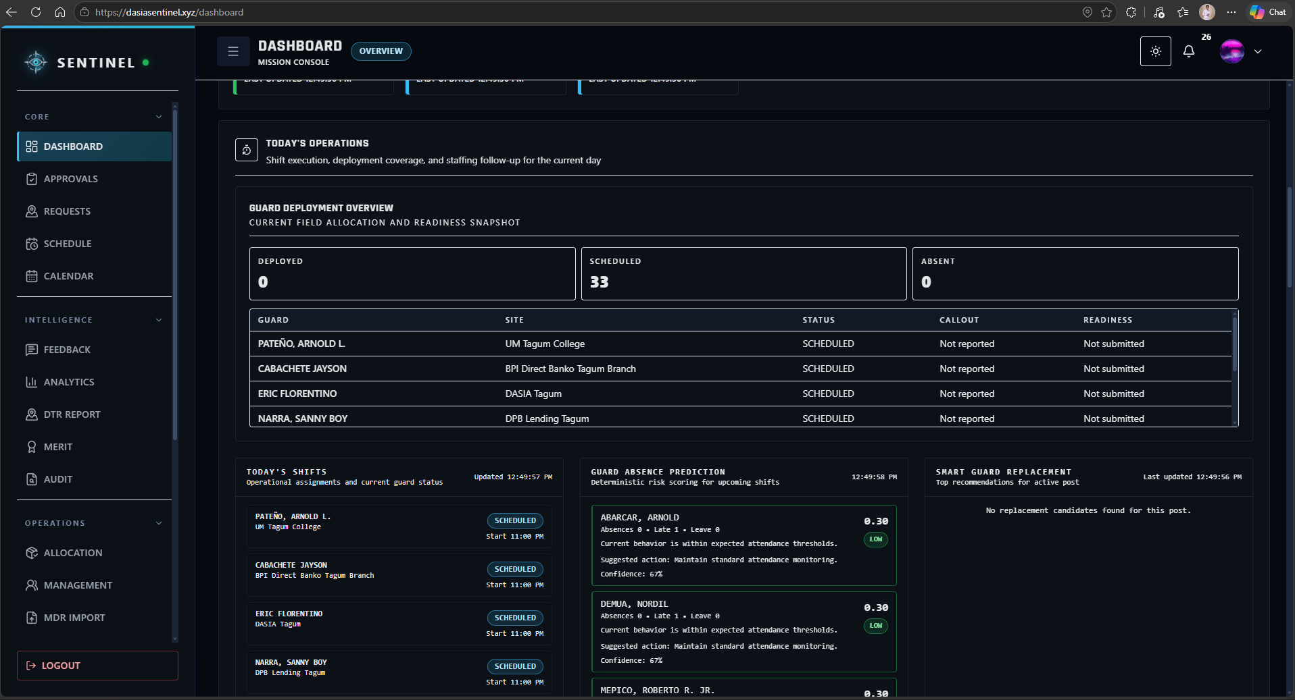
Figure 42. Guard Replacement Interface
Table 4. Quantitative Results for Personnel Operations
Assessment Description | Guard | Supervisor | Administrator | Superadmin | AWM | Equivalent
- Guard records, schedules, sites, and availability | — | 4.33 | 5.00 | 5.00 | 4.78 | Strongly Agree
- Attendance, check-in/out, DTR, and no-show monitoring | 4.85 | 4.75 | 5.00 | — | 4.85 | Strongly Agree
- Replacement recommendations and coordination | 4.83 | 4.75 | 4.50 | — | 4.79 | Strongly Agree
Mean |  |  |  |  | 4.82 | Strongly Agree
3. Firearm, Permit, Vehicle, and Asset Accountability
The firearm inventory contained 110 master records and 55 stable primary Guard-firearm mappings. The records reviewed during validation included 528 completed issue-and-return cycles, including 66 Sunday custody cycles. The checks found no firearm or Guard custody overlaps and no invalid custody chronology. Five vehicle allocations and 75 completed fleet trips were recorded without detected vehicle-trip overlaps. Incomplete imported custody information remained subject to source review. The respondents’ mean rating for asset accountability was 4.92 (Strongly Agree). Figures 43–45 show asset, permit, and vehicle interfaces.
Figure 43 presents the firearm inventory and allocation functions used to maintain firearm records, monitor availability, and preserve assignment traceability between controlled assets and authorized personnel.
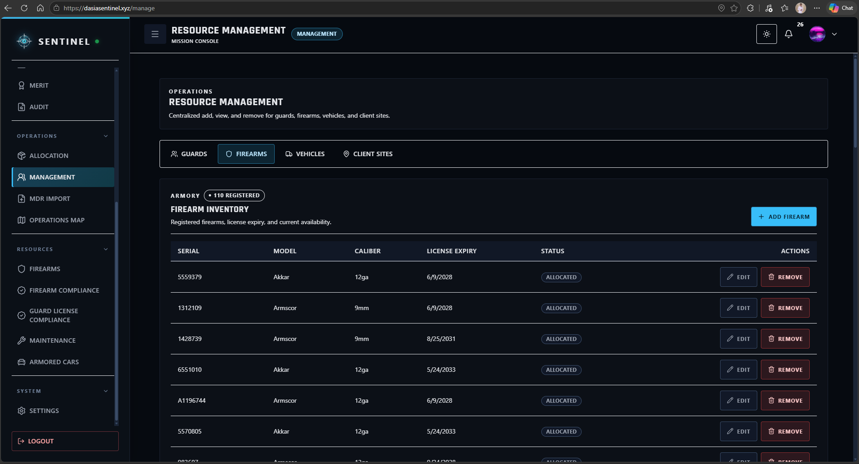
Figure 43. Firearm Inventory and Allocation Interface

Figure 44 presents the permit and compliance view used to monitor firearm-related documentation and validity information. This supports the agency in reviewing asset eligibility and compliance-related records before and during operational use.
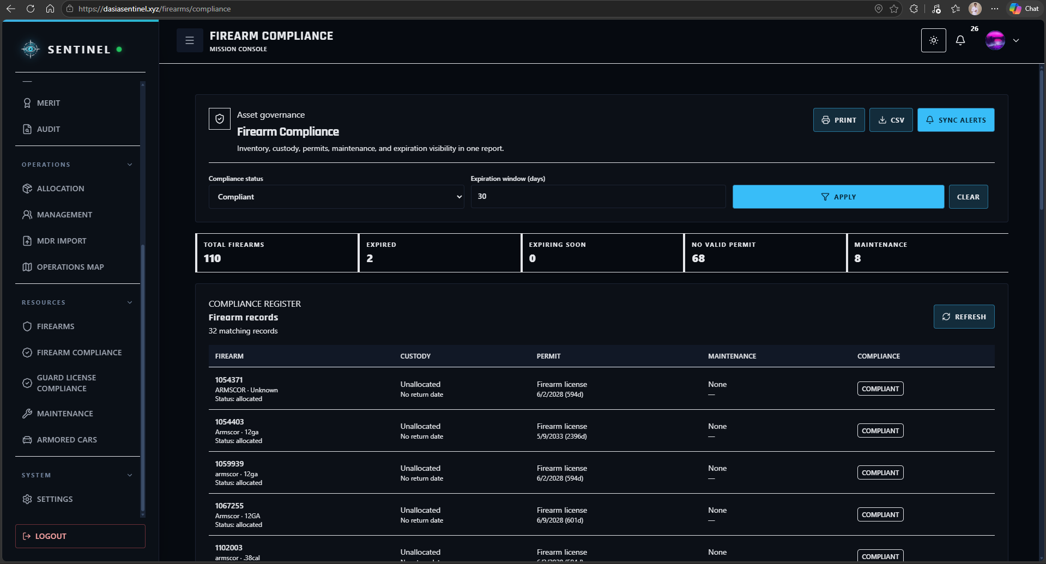
Figure 44. Firearm Permit and Compliance Interface
Figure 45 presents the armored vehicle and maintenance functions used to maintain fleet information, assignment-related records, trip readiness, and maintenance status for operational assets.
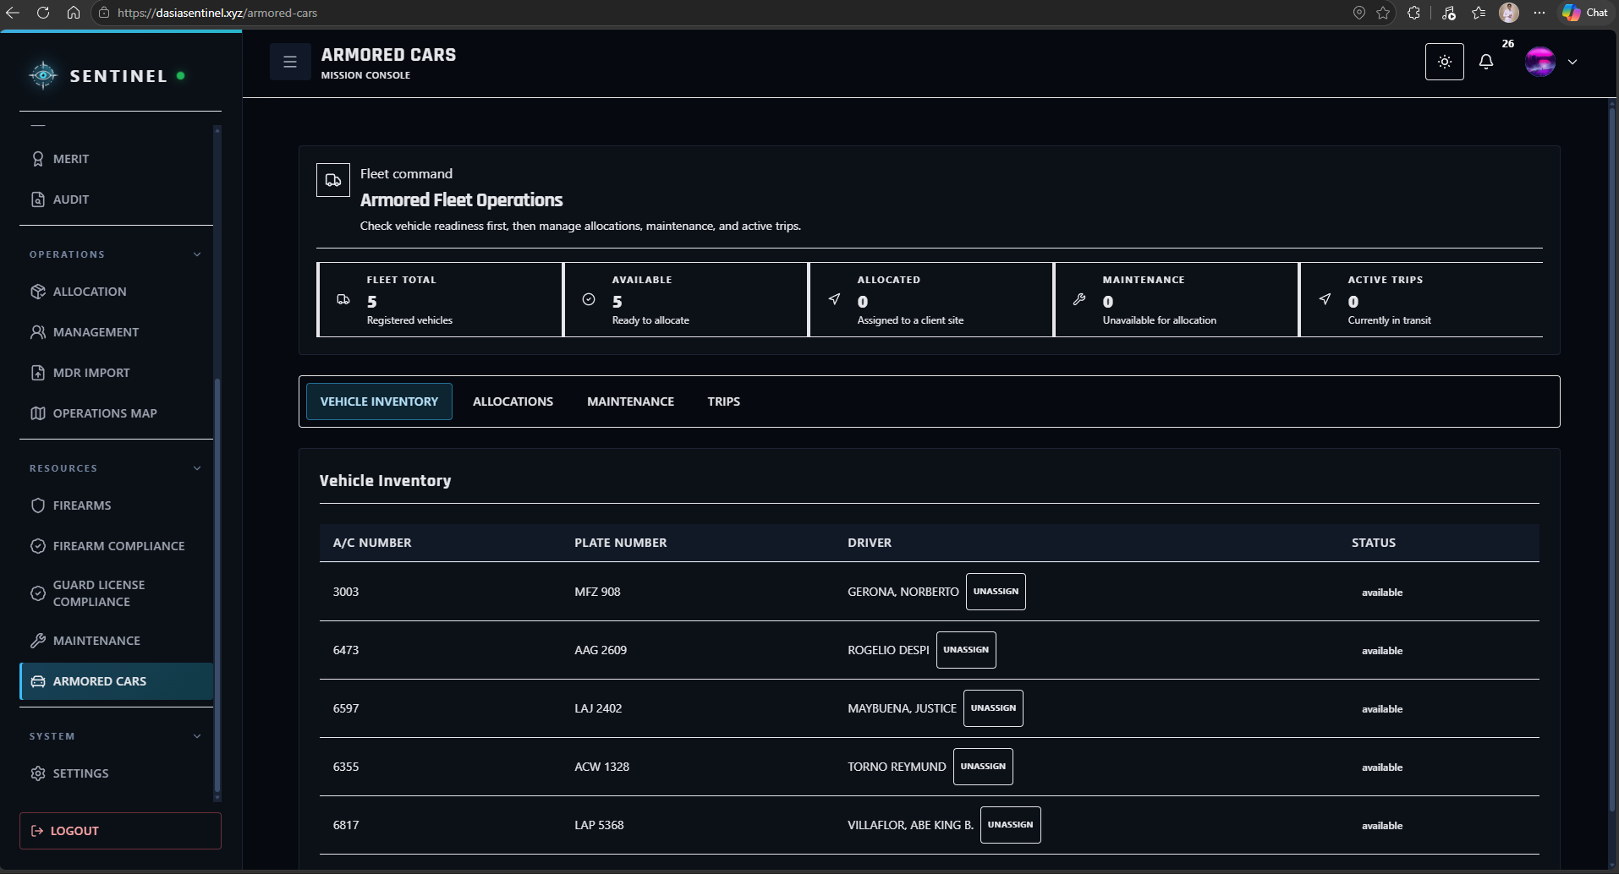
Figure 45. Armored Vehicle and Maintenance Interface

Table 5. Quantitative Results for Asset Accountability
Assessment Description | Guard | Supervisor | Administrator | Superadmin | AWM | Equivalent
- Firearm, permit, vehicle, trip, and asset records | — | 4.75 | 5.00 | 5.00 | 4.92 | Strongly Agree
- Firearm issuance, custody, return, and compliance | — | 5.00 | 5.00 | 4.75 | 4.92 | Strongly Agree
- Expiration, maintenance, asset alerts, and reports | — | 5.00 | 4.75 | 5.00 | 4.92 | Strongly Agree
Mean |  |  |  |  | 4.92 | Strongly Agree
4. Field Operations, Incident Handling, Notifications, and Live Monitoring
The field modules supported incident reporting, requests, emergency escalation, notifications, support, and authorized location monitoring. The records reviewed during validation included seven incidents, nine requests with 22 history events, 23 notifications, seven support tickets, and tracking records. Map queries excluded stale records from current-location displays. The respondents’ mean rating for field operations was 4.85 (Strongly Agree). Figures 46–48 show the Operations Map, incident, and Inbox interfaces.
Figure 46 presents the Operations Map used by authorized command users to review deployment locations and field context. The map supports situational awareness by combining client-site information with available location and operational data.
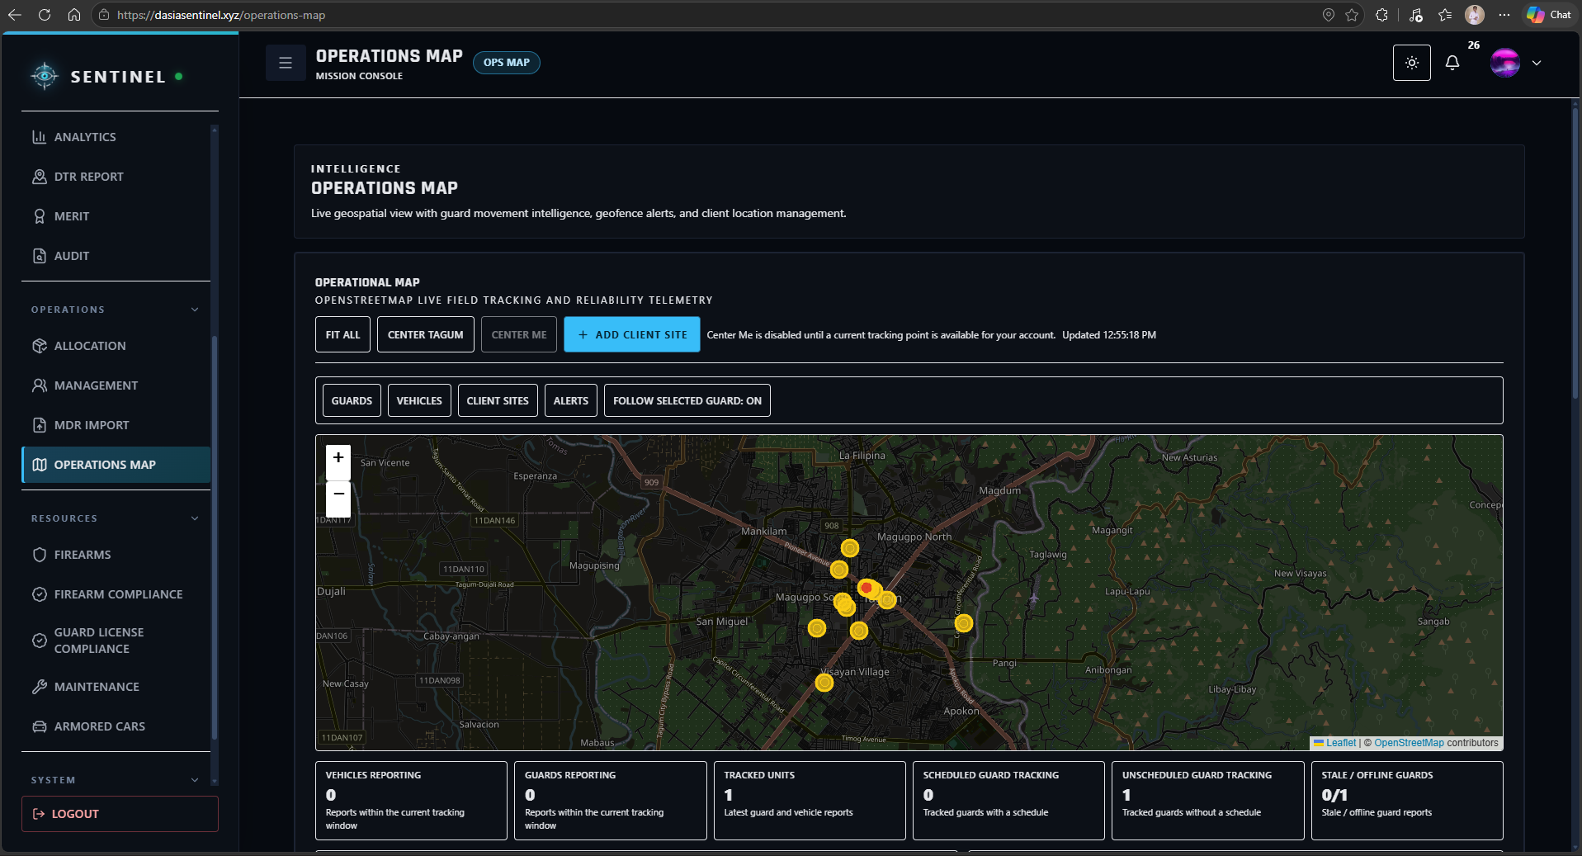
Figure 46. Operations Map and Live Monitoring Interface

Figure 47 presents the incident workflow used to record and review field events. Incident records provide structured information that can be classified, monitored, and followed up by authorized personnel.
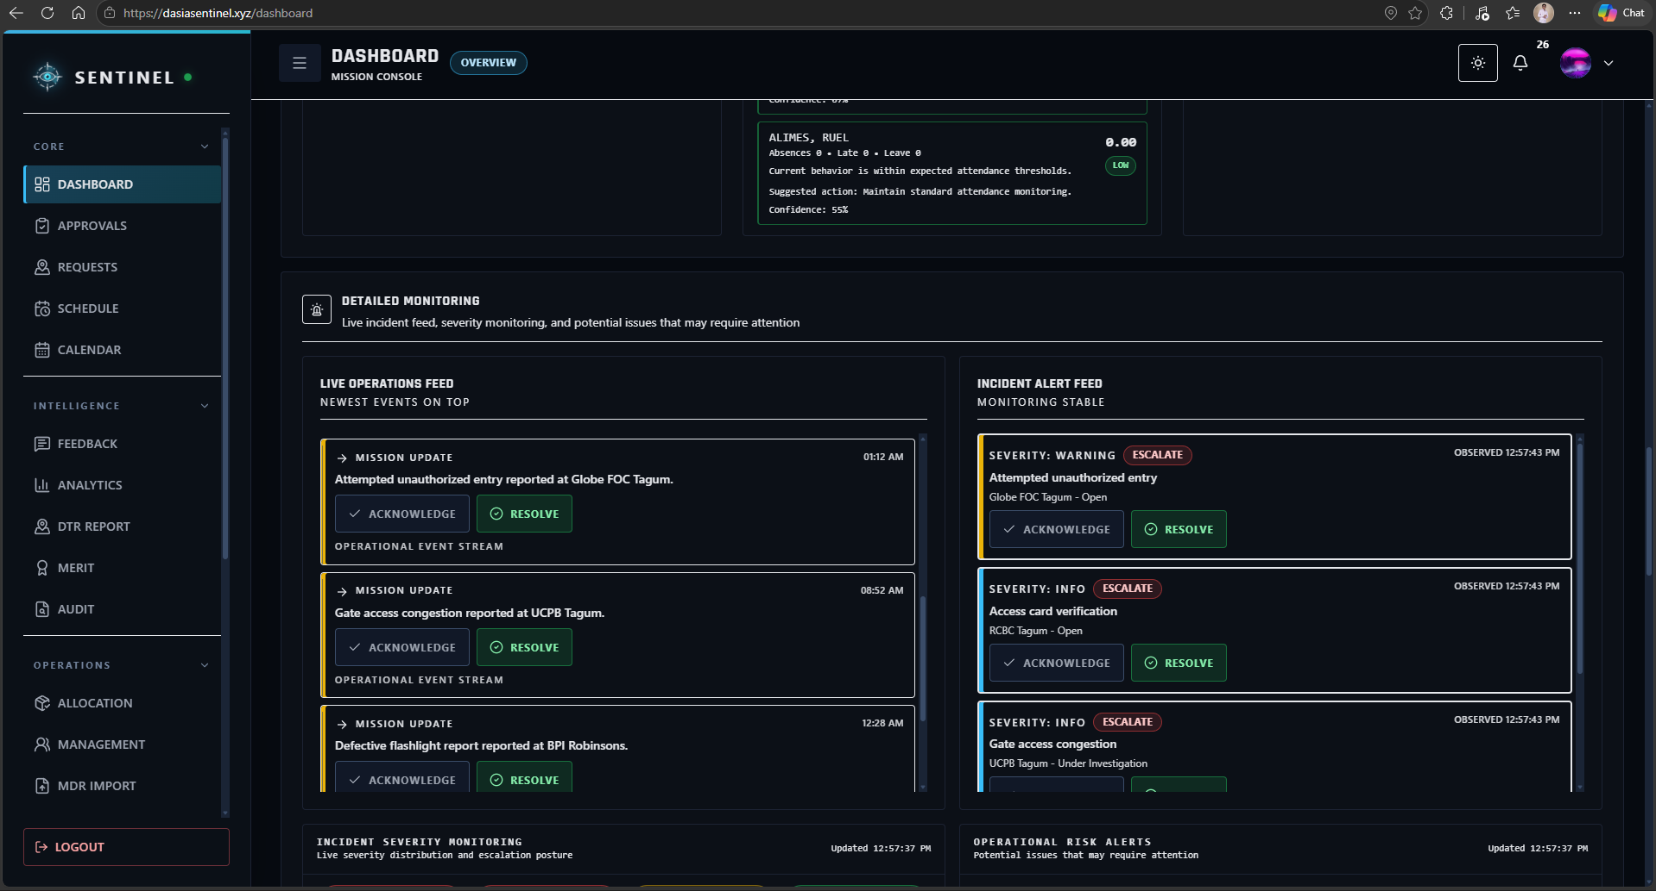
Figure 47. Incident Reporting and Review Interface

Figure 48 presents the communication and support functions used to surface operational notifications, pending items, supervisor messages, and support-related concerns. These functions provide users with a centralized channel for field coordination and follow-up.
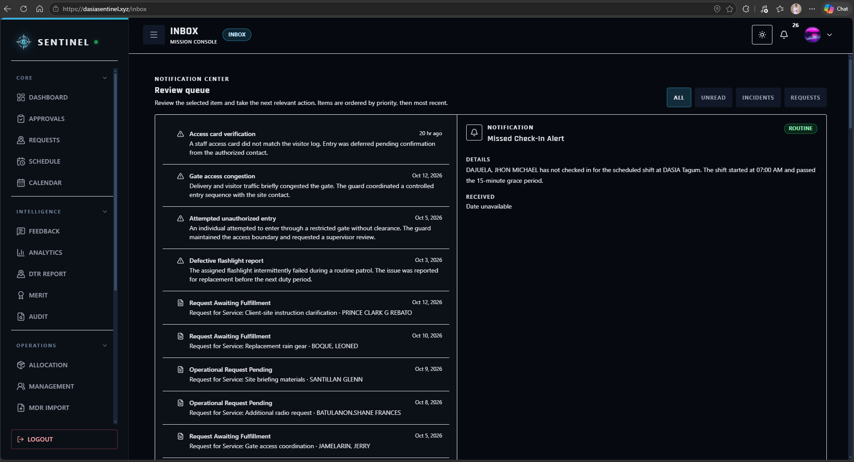
Figure 48. Inbox, Notification, and Support Interface
Table 6. Quantitative Results for Field Operations
Assessment Description | Guard | Supervisor | Administrator | Superadmin | AWM | Equivalent
- Incidents, support, emergencies, and SOS | 4.80 | 4.75 | 5.00 | — | 4.81 | Strongly Agree
- Location, movement, geofence, and Operations Map | 4.92 | 5.00 | 5.00 | 5.00 | 4.94 | Strongly Agree
- Notifications, Inbox, missions, and updates | 4.85 | 4.75 | 4.25 | 4.25 | 4.75 | Strongly Agree
Mean |  |  |  |  | 4.85 | Strongly Agree
5. Performance Evaluation and Analytics
Analytics drew on 55 merit scorecards, 24 client evaluations, and punctuality information in the records reviewed. Four rule-based absence-risk scenarios were checked separately. These indicators supported review by authorized users; they were not validated machine-learning predictions. The respondents’ mean rating for performance evaluation and analytics was 4.85 (Strongly Agree). Figures 49 and 50 show the analytics and evaluation interfaces.
Figure 49 presents the Analytics dashboard used to review attendance, punctuality, assignment, incident, and Guard-performance information. The visual summaries support command users in identifying patterns and reviewing operational conditions from centralized records.
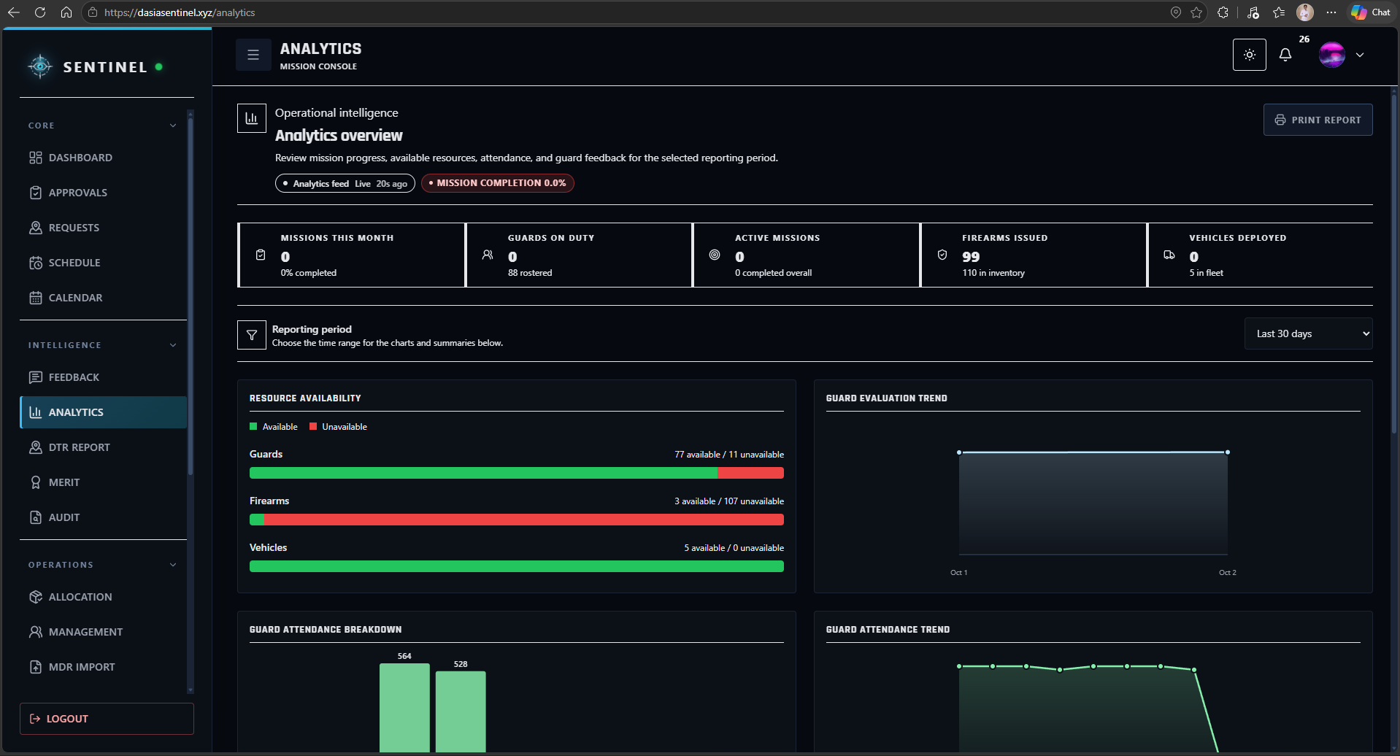
Figure 49. Performance Analytics Dashboard

Figure 50 presents the performance and evaluation information used to review Guard merit indicators, client evaluations, and related decision-support outputs. These records provide a structured basis for personnel assessment and supervisory review.
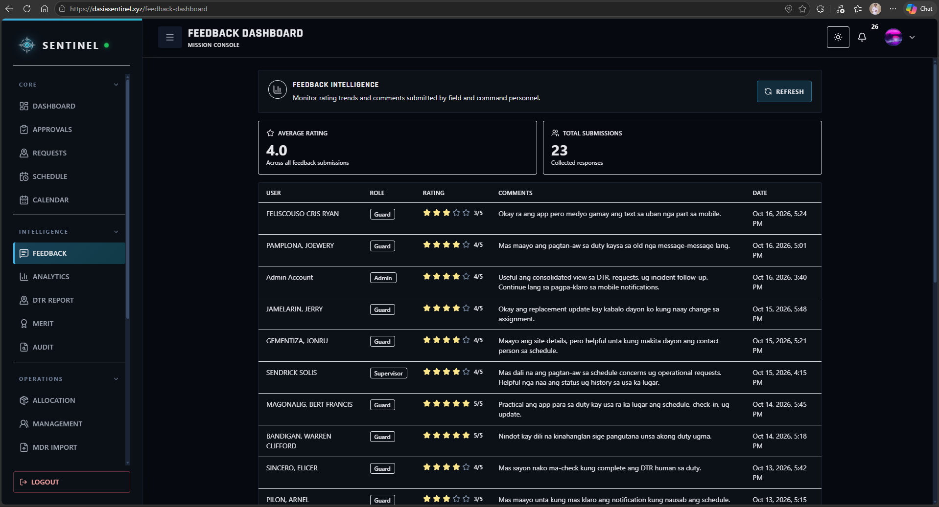
Figure 50. Guard Performance and Evaluation Interface
Table 7. Quantitative Results for Analytics
Assessment Description | Guard | Supervisor | Administrator | Superadmin | AWM | Equivalent
- Attendance, incident, assignment, and performance reports | — | 4.67 | 5.00 | 5.00 | 4.89 | Strongly Agree
- Rule-based scores, risks, and recommendations | — | 4.67 | 5.00 | 5.00 | 4.89 | Strongly Agree
- Dashboards and decision-support information | — | 5.00 | 4.67 | 4.67 | 4.78 | Strongly Agree
Mean |  |  |  |  | 4.85 | Strongly Agree
6. Traceable Multi-Platform Delivery and Operational Reporting
The hosted Web application and API returned HTTP 200 in the final availability check. Audit and reporting workflows recorded actors, timestamps, actions, and operational information for authorized review. The Windows desktop and Android applications were installed and tested on their intended platforms. The respondents’ mean rating for traceability and reporting was 4.90 (Strongly Agree). Figures 51–53 show audit, reporting, and responsive access; Figure 53 depicts mobile Web access.
Figure 51 presents the Audit interface used by authorized users to review recorded system actions, security events, and traceable operational activity. The audit workspace supports accountability, governance review, and post-event investigation.
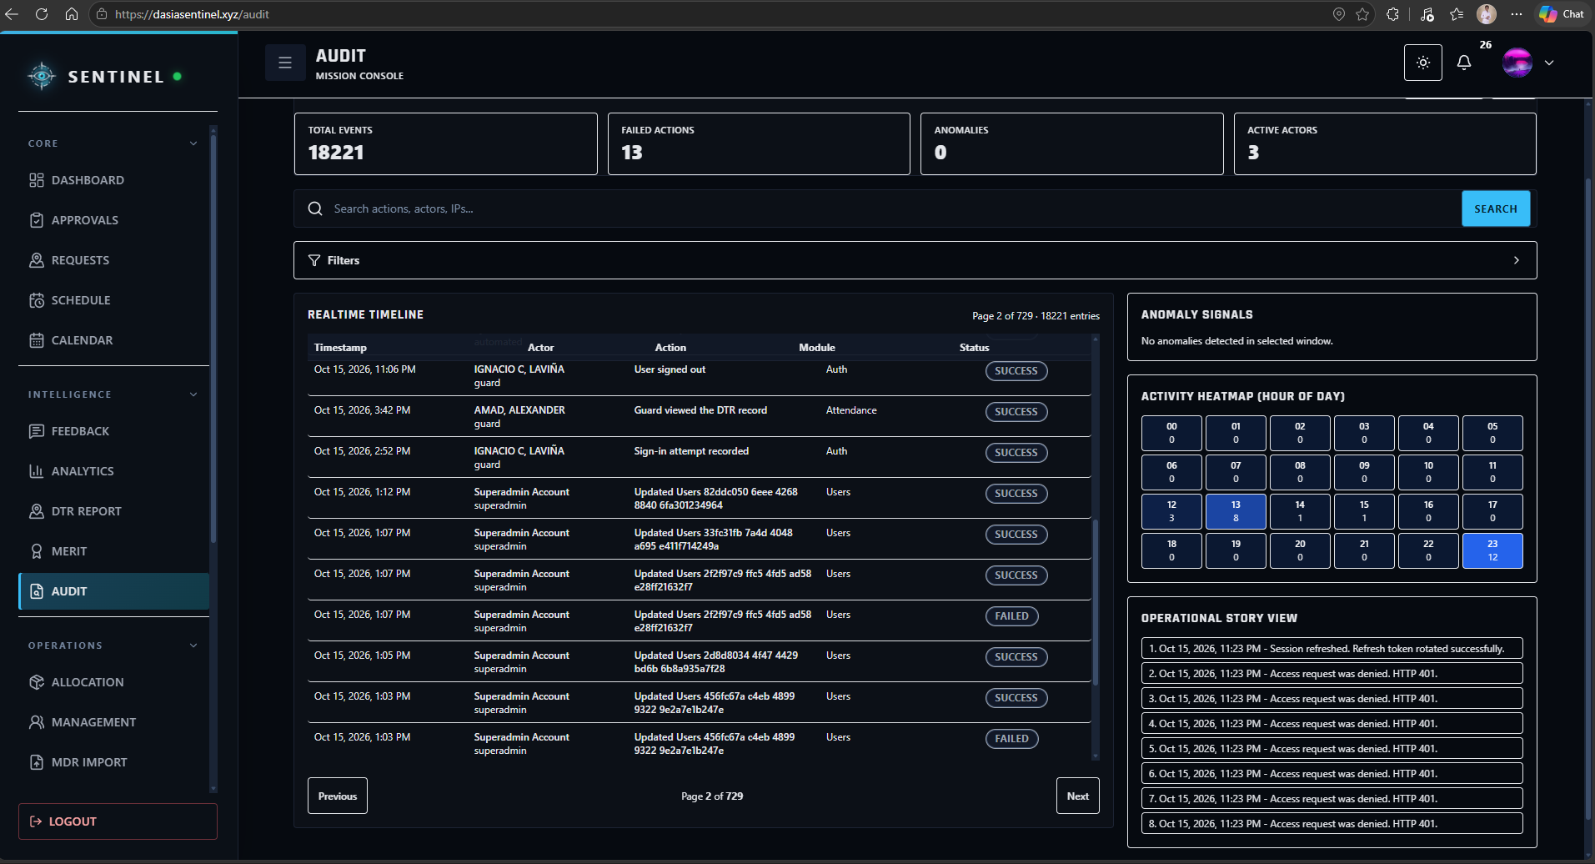
Figure 51. Audit and Traceability Interface

Figure 52 presents the reporting or export function used to produce operational records in a form suitable for review, documentation, and institutional monitoring. This supports the objective of maintaining traceable operational and compliance information.
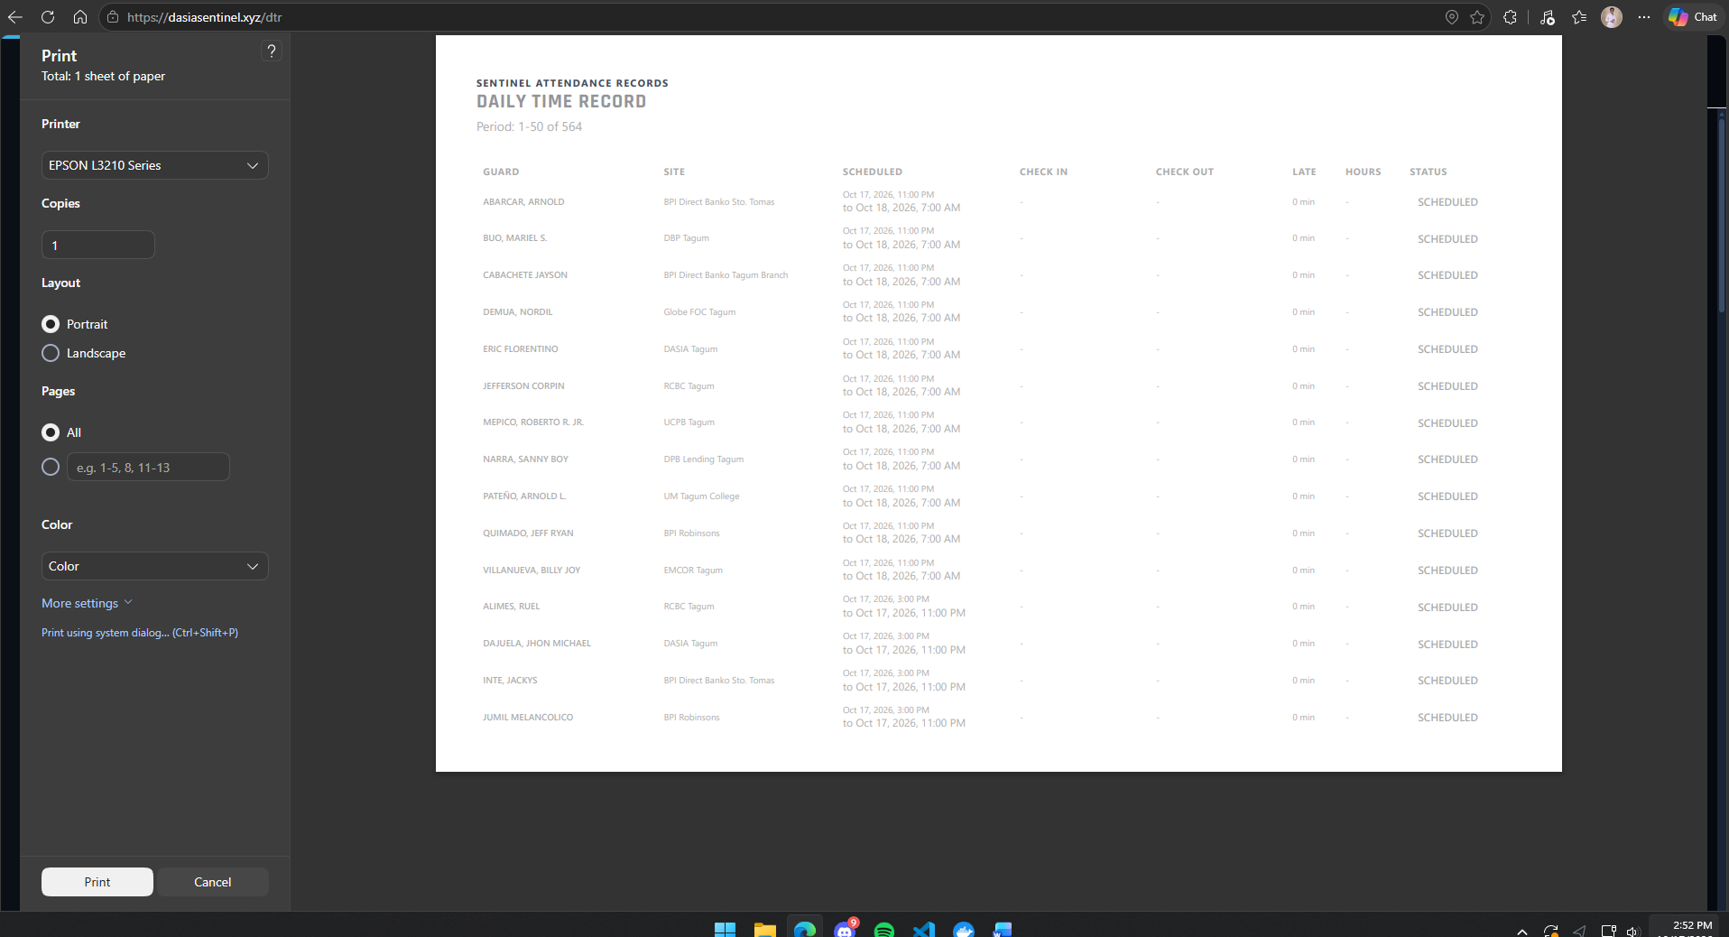
Figure 52. Operational Report and Export Interface
Figure 53 presents the Guard interface in a responsive mobile browser layout. It illustrates mobile Web access to the shared application.
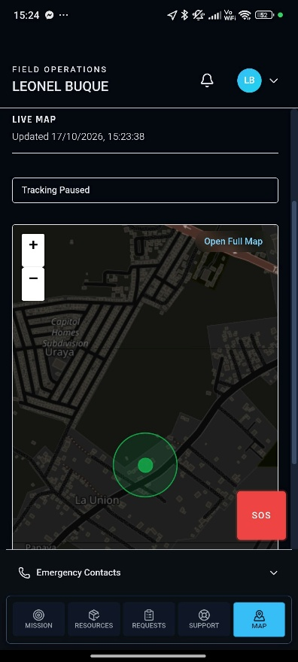
Figure 53. Responsive Mobile Guard Interface

Table 8. Quantitative Results for Traceability and Reporting
Assessment Description | Guard | Supervisor | Administrator | Superadmin | AWM | Equivalent
- Access through the Web, Windows desktop, and Android applications. | 4.91 | 4.71 | 4.86 | 4.86 | 4.89 | Strongly Agree
- Audit, approval, security, and action traceability | — | — | 5.00 | 5.00 | 5.00 | Strongly Agree
- Operational and compliance reports | — | 5.00 | 4.75 | 5.00 | 4.92 | Strongly Agree
Mean |  |  |  |  | 4.90 | Strongly Agree

Summative Quantitative Evaluation
The completed questionnaires produced the following quantitative evaluation results. A dash indicates that a role did not receive the corresponding assessment item. The interpretation used was 4.21–5.00 Strongly Agree; 3.41–4.20 Agree; 2.61–3.40 Fairly Agree; 1.81–2.60 Disagree; and 1.00–1.80 Strongly Disagree. The quality-attribute grand mean calculated from 572 applicable ratings was 4.86.
Table 9. Summary of User Rating by System Quality Attribute
Quality Characteristic | Mean | Descriptive Equivalent
Functional Suitability | 4.88 | Strongly Agree
Performance Efficiency | 4.83 | Strongly Agree
Compatibility | 4.92 | Strongly Agree
Usability | 4.84 | Strongly Agree
Reliability | 4.85 | Strongly Agree
Security | 4.86 | Strongly Agree
Portability | 4.92 | Strongly Agree
Grand AWM | 4.86 | Strongly Agree

Respondent Comments
The Guard comments described the schedules, attendance, DTR, replacement information, and notifications as understandable. Several reported slower map loading or updates when mobile data was weak and requested clearer duty-change alerts or larger mobile text. The comments identified notification visibility, mobile readability, connectivity-related responsiveness, and dashboard performance as areas for refinement.
The Supervisor comment described scheduling and replacement information as helpful for finding available personnel. The Administrator did not provide a comment, while the Superadmin comment raised dashboard loading as data grows. Connectivity, notification visibility, mobile readability, and dashboard performance were recurring themes in the respondent comments.

CONCLUSION

Summary of Key Findings
SENTINEL was developed as an integrated security operations system with role-governed access, scheduling, attendance and DTR, replacement, firearm custody, fleet trips, incidents, requests, notifications, monitoring, analytics, and audit records. The implementation covered 55 Guards across 11 client-site rosters, 564 tracked shifts, 528 completed attendance records, and three replacement assignments. Final consistency checks reported no overlapping assignments or insufficient-rest violations.

Evaluation of the Project
The system validation recorded 110 firearm master records, 55 stable Guard-firearm mappings, 528 completed issue-and-return custody cycles, five vehicle allocations, and 75 completed fleet trips. The system evaluation produced a 4.86 Grand Average Weighted Mean, interpreted as Strongly Agree.
The completed technical checks supported the tested workflows, while weak mobile connectivity, notification visibility, mobile readability, and dashboard response remained areas for refinement. The Windows desktop and Android applications also completed installation and runtime testing on their intended platforms.

Implications and Contributions
SENTINEL linked Guard assignments with attendance and replacement records, firearm issuances with individual custody entries, and vehicle allocations with trip history. The system also stored incidents, notifications, and user actions for review through the relevant modules and audit records. These linked workflows were the project’s contribution to managing personnel, assets, and field records in one role-governed system.

Recommendations
Periodic reconciliation of operational records, database backups, audit review, and consistency checks should be continued to maintain data integrity.
Notification prominence, mobile text readability, map loading, and dashboard response under slow network conditions should be improved. Query optimization, pagination, caching, and retry handling should be assessed as records grow.
Firearm permit, training, and custody information should be verified against source records, with periodic inventory reconciliation, database backups, controlled migrations, permission checks, and audit review.
Rule-based merit, risk, and replacement indicators should remain transparent decision-support tools. Any future predictive or machine-learning function should be validated separately before operational use.

REFERENCES

Abad, R. (2025). How Effective Is Your Security Guard? An Inquiry into the Philippine Private Security Industry. Retrieved from https://doi.org/10.13140/RG.2.2.30981.41442
Aguinis, H. (2022). Performance Management (5th ed.). SAGE Publications. Retrieved from https://edge.sagepub.com/aguinispm5e
Al-Khafajiy, M., et al. (2022). Enabling high performance fog computing through fog-2-fog coordination model. Future Generation Computer Systems. Retrieved from https://doi.org/10.1016/j.future.2022.06.012
Atlam, H. F., & Yang, Y. (2025). Enhancing Healthcare Security: A Unified RBAC and ABAC Risk-Aware Access Control Approach. Retrieved from https://doi.org/10.3390/fi17060262
Department of Information and Communications Technology (DICT). (2024). National Cybersecurity Plan 2023-2028: A Whole-of-Nation Roadmap. Retrieved from https://dict.gov.ph/national-cyber-security-plan
GetApp. (2026). Guardhouse 2026 Pricing, Features, Reviews & Alternatives. Retrieved from https://www.getapp.com/operations-management-software/a/guardhouse/
Hardcat. (2025). Law Enforcement Equipment & Armory Management System: Challenges in Managing Firearms Securely. Retrieved from https://hardcat.com/police-equipment-inventory-tracking/
Jur.ph. (2025). The Private Security Services Industry Act: Law Summary and IRR. Retrieved from https://jur.ph/law/summary/the-private-security-services-industry-act
Khinvasara, T., Shankar, A., & Wong, C. (2024). Survey of Artificial Intelligence for Automated Regulatory Compliance Tracking. Retrieved from https://doi.org/10.9734/jerr/2024/v26i71217
NashTech. (2025). Building High-Performance Web Services with Rust and Axum. Retrieved from https://blog.nashtechglobal.com/building-high-performance-web-services-with-rust-and-axum/
NEDA XI. (2024). Davao Regional Development Plan 2023-2028. National Economic and Development Authority. Retrieved from https://rdc11.neda.gov.ph/rdc-xi-approves-davao-regional-development-plan-2023-2028/
Nguyen, R. (2025). PostgreSQL ACID In-Depth: Reliability and Consistency in Modern Transactions. Retrieved from https://medium.com/engineering/postgresql-acid-in-depth
NODE Magazine. (2026). Why 2026 is the Year Businesses Must Finally Address Admin Overload. Retrieved from https://www.node-magazine.com/thoughtleadership/why-2026-is-the-year-businesses-must-finally-address-admin-overload
Ondos, M. U., & Origines, D. V. (2025). Android-Based Guard Monitoring and Site Surveillance System. Retrieved from https://www.ojs.udb.ac.id/icohetech/article/view/5657
PIA. (2025). Davao City Maintains Top Safety Ranking in Southeast Asia. Philippine Information Agency. Retrieved from https://pia.gov.ph/news/davao-city-maintains-top-safety-ranking-in-southeast-asia/
PostgreSQL Global Development Group. (2025). PostgreSQL 17 Documentation: Data Integrity and ACID Compliance. Retrieved from https://www.postgresql.org/docs/17/acid.html
PNP-SOSIA. (2022). Implementing Rules and Regulations of Republic Act No. 11917. Retrieved from https://www.scribd.com/document/691228276/Approved-IRR-RA-11917
Republic Act No. 11917. (2022). The Private Security Services Industry Act. Retrieved from https://elibrary.judiciary.gov.ph/thebookshelf/showdocs/2/95597
Scofield, M. B. (2025). Rust Axum Web Development: Build High-Performance APIs and Services. Retrieved from https://www.amazon.com/Rust-Axum-Web-Development-High-Performance/dp/B0CX7N4K6J
Securitas. (2026). Control Security from Anywhere - MySecuritas Product Overview. Retrieved from https://www.securitas.com/en/security-solutions/mysecuritas/
Securitas Technology. (2025). 2026 Global Technology Outlook Report: The State of Security Technology. Retrieved from https://www.securitastechnology.com/news/securitas-technology-releases-2026-global-technology-outlook-report
Shiyanbola, J. O., et al. (2023). A Workforce Capacity Optimization Model for Lean Environments. Retrieved from https://www.irejournals.com/paper-details/1704408
Tan, K., et al. (2024). The digital transformation of security and the role of AI. Securitas White Paper. Retrieved from https://www.securitas.ie/news-insights/whitepapers/the-digital-transformation-of-security-and-the-role-of-ai/
TrackTik. (2025). Top 5 End-to-End Security Guard Management Software for 2025. Retrieved from https://www.tracktik.com/resources/blog-articles/top-5-end-to-end-security-guard-management-software-for-2025/
TrackTik. (2025). Physical Security Operations Benchmark Report 2025. Retrieved from https://www.tracktik.com/wp-content/uploads/2025/10/2025BenchmarkReport-1.pdf

